# An Exploration of Wartime Propaganda in Social Media

# TODOs:

Table of contents

Summary

Links for figures, tables, citations

Fix references

Fix figures to include legend

Discuss results more

Check how I need to quote tweets, copyright etc.

Mention that these tweets are aimed at a western audience

Add github link somewhere

# Introduction

#### Purpose of this study

This thesis aims to examine how propaganda is used in social media during a state of war. In particular, I evaluate multimodal – text and image - Twitter data from Russian and Ukrainian governmental organizations and state-affiliated politicians concerning the 2022 Russian invasion into Ukraine and the ongoing Russo-Ukrainian War. This examination is done on multiple levels. First, the data is manually annotated according to the propaganda types found within the text or image. After that, several state-of-the-art textual and multimodal models are used to evaluate whether the propaganda within the data is easy to categorize, and whether it is comparable to another multimodal type of media – memes. A statistical analysis follows, evaluating which types of propaganda are used more frequently on a national, as well as a organizational level. Whether some types are particularly helpful for propaganda on social media is explored as well. The final part consists of a manual analysis, examining some narratives found in the data, and exploring why they are used. Sections supplying the statistical analysis with concrete examples from the dataset can be found here as well. This is followed by a conclusion, a discussion on the limits of the study, and suggestions for future work.

This paper is structured as follows. First, an introductory section, detailing what propaganda is, as well as its relation to war, social media, and cognition, is given. It is followed by a section on the particular types of propaganda examined in this thesis, as well as background on computational propaganda. Next comes the methods section, detailing the data, how it was was collected, cleaned and annotated. This is followed by a description of the experiments done with machine learning models and an evaluation of the results. After this, a section detailing the statstical methods used, as well as the results from them is presented. Building on the results of the machine learning and statistical analyses, a manual analysis of some of the trends noticed within the data is done. The paper is concluded with an overview of the work done here, limitations observed while doing it, and considerations for further work.

A number of research questions are explored within this paper. First, the use of multimodal models has been shown to lead to a good classification accuracy for memes with hateful sentiments (Kiela, Firooz, et al., 2020) and memes with propaganda (Dimitrov et al., 2021). The experiment with machine learning models will explore whether good accuracy can be gained for the corpus of this paper – twitter messages with propaganda. Based on previous research on the impact of modalities (Kiela, Bhooshan, et al., 2020), it is expected that text will contribute the most to a successful classification, but images will increase the overall accuracy as well. Second, the thesis will evaluate what kinds of propaganda are used more often than others, whether there are any distinctions on the Russian-Ukrainian as well as individual-organization levels, and whether some types of propaganda are more beneficial to use on social media than others. Finally, the particular types of images and text are investigated in a qualitative manner, and the narratives that unfold in the collected corpus are explored.

#### What is propaganda and why is it important?

*Propaganda* is a term with many interpretations. Jacques Ellul defined it as a technique of psychological manipulation, and considered it “an indispensable condition for the development of technological progress” (Ellul, 2021). Shawn J. Parry-Giles saw it as “strategically devised messages <...> for the purpose of generating action benefiting its source” (Parry-Giles, 2002). In general, the term *propaganda* means to disseminate or promote particular ideas, and the word itself is often used in a negative sense. When we use *propaganda* to denote purpose, it is regarded as a way of conveying an ideology to an audience, seeking to reinforce or modify its attitudes, behavior, or both. It is used by all kinds of individuals and organizations – governmental and private, reactionary and revolutionary, left- and right-leaning, militaristic and pacifistic. It is a way of delivering a message that is easily understood and has a quick, strong impact on the audience (Jowett & O’Donnell, 2011).

Propaganda has existed throughout all ages. Confucius, in his *Analects,* emphasizes “skillfulness in speech”, and warns against what might be perceived as propaganda in modern days: “You show approval of him because he seems sincere in what he says. But is he truly a gentleman, or does he simply put on a dignified appearance?” (Confucius, n.d.). In ancient civilizations, institutional propaganda was often produced in the form of monuments for the rulers, such as the Pyramids in Ancient Egypt (Schilling, 1941). Because war was a common activity, establishing the basis for war was partly done by exemplifying the differences between the warring civilizations, and the unique culture, such as statues of the gods popular in the specific area, were used both to signify the strength of the state as well as a propaganda piece to further the “us versus them” narrative (Jowett & O’Donnell, 2011). In the 20th and 21st centuries, propaganda evolved, with governments around the world forming organizations tasked with producing their own, as well as discrediting enemy propaganda. This evolution came with a change in form as well: mass-produced posters, radio, films, television, and finally, social media, became the primary forms of communication, and thus propaganda.

Propaganda is a powerful tool that is often used to deceive individuals or, in some form, shroud the truth. This can range from relatively harmless actions, such as advertisements for products, to productions with huge consequences, such as media campaigns intent on justifying war. It is therefore imperative that we understand how propaganda works, which types of it are used, which ones are useful, and what action can be taken to counteract it. It has been shown that when hate speech is exposed as such, it tends to lose its power (Denton, 2000, as cited in Bondarenko, 2020) – such is the case with propaganda as well.

#### Propaganda and War

A state of war requires a shift in social dynamics. This takes on various forms: a move towards war economy, the introduction of conscription, food rationing, an increase in media censorship. All of these choices require a justification to the public – otherwise, support for the war may go down, which would require the state to withdraw. Propaganda is an effective way of establishing why these changes are required, and it has thus been used widely during modern wars.

Purpose of propaganda during war

The actions taken by governments during wars are often detrimental to an individual, reducing both their rights and their quality of life. Because of this, an important purpose of propaganda during wartime is to convince people that the sacrifice of individualism for the purpose of a “greater good” is a worthy endeavor (Laskin, 2019). Laskin states that J.F. Kennedy’s famous statement “ask not what your country can do for you, ask what you can do for your country” is “the quintessence of propaganda”. McCrann (2009) agrees, noting the common use of the word “we” in propaganda, which has two purposes. First, it establishes the individual as part of the group. McCrann notes that people identifying with a group may do activities that help the group, even if they are detrimental to the individual, as well as validate the group’s behavior, while the group validates theirs, making the social identity of a person act as a “social glue” (Van Vugt & Hart, 2004). Second, it implies an antagonistic group of “them”, using the social dynamics of in- and outgroups to, among other things, dampen empathetic feelings towards the enemy (Cikara et al., 2011).

Forms of propaganda during war

Another factor to consider is the forms of propaganda used during war. In the two world wars, propaganda posters issued by governments were used for communicating public policy (McCrann, 2009). Posters are an useful form of communication, because they can deliver a multimodal message: both the image, and the (optional, but often used) accompanying text can have meanings that reinforce each other. Images can tap directly into a communication based on entrenched cultural and historical values (Aiello & Parry, 2019), while text may be used for a more direct message or an implied course of action. McCrann (2009) notes how using an image of a strong man, wearing working clothes, with dirt on his hands, surrounded by a range of middle-class men sitting and listening to him, “reinforces the concept of a historical commitment to American values, character, and citizen governance”. The accompanying text, “Save Freedom of Speech – Buy War Bonds”, while not being directly related to the image, suggests to the reader a course of action for retaining this image of a free nation and becoming part of it. As another example, McCrann (2009) notes how the Japanese government used the image of a cherry blossom, a well known historic symbol of the samurai, in combination with images of kamikazes, painting these fatal missions as noble, respectable efforts.

In the last 20 years, the Internet, in particular social media, have become a popular source of information, and they have been exploited to deliver propaganda during wartime. The 2011 revolution in Egypt initially started as a protest event on the social networking website Facebook, and the Internet was widely used by protesters to exchange information, organize events, as well as deliver real-time updates on the ongoing revolution (El-Khalili, 2013). Governmental organizations were not initially active online, but after seeing the power this new form of communication can have, moved quickly to take over. Various state-affiliated groups, including the parliament, the army, as well as individual ministries created social media accounts, and started using them more often (Ghannam, 2011). In particular, the Supreme Council of the Armed Forces (SCAF) began using social media for communicating directly with the citizens. With the unique role SCAF played in the revolution, starting out in support of the revolutionaries, but later taking over power and becoming rulers, a change in their communication could be observed (Naguib, 2011), initially coming out with messages stating that the army would protect the revolutionaries and act merely as “guardians of the revolution”, shifting over time to acting as “bearers of stability” and promising to lead the country back to a normal life, and finally branding the revolutionaries as thugs and painting the revolutionary youth as enemies of the nation.

#### Propaganda and Social Media

As mentioned before, propaganda took on new forms with the advent of the Internet and social media. The Internet offers a unique environment for the spread of disinformation, unverified facts, and a mix between news and rumours, sometimes called “paranews” (Dowe, 1997). It did not take long for political propaganda to make way to it. In fact, an entire ecosystem of propaganda exists solely within the Internet – media companies created to spread particular ideas, real and fake accounts of individuals spreading these same ideas on social media, thus appearing more credible, as well as websites made for the sole purpose of divulging the political biases – both in content and control – the aforementioned companies have (Jowett & O’Donnell, 2011). While propaganda is strongest when it comes from a centralized, authoritative source, social media allows any individual the power to spread their message, as there is little to no upfront cost and no journalistic ethics to consider. New platforms for engagement emerge often, and many people use social media as a source of news (Walker & Matsa, 2021).

Even though social media allow smaller organizations and individuals to spread the message, state-affiliated groups have been noted to disseminate propaganda via the Internet as well. An extensive research into how Russia uses social media found that there are multiple points of attack: social media operations focusing on the near abroad, where a significant amount of the population speaks Russian and there are historical and cultural ties; operations focusing on the far abroad, such as the 2016 U.S. election; as well as pro-Russian social media accounts that may not be directly affiliated with the state, but receive support from it (Helmus et al., 2018a). The research also separates their means into three different levels: “white” outlets, such as official governmental accounts and state-affiliated news websites, “gray” outlets, such as conspiracy websites, radicalised political accounts and news aggregators, as well as “black” outlets, such as bot farms and fake accounts. These efforts have countable effects: people that engaged with Russia-based media tended to be more accepting of Russian narratives, such as the U.S. government’s fault in the Russo-Ukrainian war (Gerber & Zavisca, 2016).

[chinese propaganda?]

[targets of propaganda]

#### Propaganda and Cognition

[propaganda and war return here]

[lakoff here perhaps]

Propaganda should be considered from the cognitive perspective as well. As there are a lot of different types of propaganda (discussed more thoroughly in the *Methods* section), it would be useful to know the psychological reasons why some types work, and whether some work better than others.

In her research on the cognitive underpinnings of propaganda, Bondarenko (2020) discerns four different types of explicit propaganda and considers their uses. First, the purpose of converting an individual construal of the world to a collective one is reiterated, as mentioned in section [purpose of propaganda section]. However, contrary to Laskin and McCrann, Bondarenko considers this involvment in a group an illusion for the individual, as the opinions and ideas of the group are not initially inherent in or natural for the person targeted by this propaganda. The types of propaganda used for this task are *reference to authority* and *support group*. Second, Bondarenko underlines the use of emotion in propaganda. Emotions allow an instinctual or socially conditioned shift in mood for the targets of propaganda (Forgas & Koch, 2013). In political propaganda, negative emotions, such as fear, anger, or sense of guilt are most common, as they can easily be connected to an enemy; however, emotions such as compassion are sometimes appealed to as well. The emotional is used over the rational, as it allows for a conceptual entrenchment in memory, and thus, an effect that lasts longer (Bondarenko, 2020).

Third, reality is distorted by means of transforming or substituting some aspects presented in the propaganda piece. Here Bondarenko refers to joint attention and how methods such as *false analogies, re-scaling* and *local absence of alternative* are used to, in cognitive terms, substitute the anchor of joint attention (Tomasello, 1995) for an alternative, distorted one. This can be done in a number of ways: *false analogies* use some form of real relations as an anchor (such as a large number of Ukrainians knowing how to speak Russian) and replace that with a propagandistic anchor (a large number of people living in Ukraine *are* Russian). *Re-scaling* intensifies or diminishes the importance of a real anchor (such as the debt a country has accrued); *local absence of alternative* supposes that a proposed idea is inherently correct since there are (locally) no realistic alternatives.

Finally, Bondarenko (2008) considers word triggers: words, phrases or statements that trigger a picture or concept in the targets’ minds. These can be culturally related symbols, like the cherry blossoms mentioned above, but they can also be normal words that have become conceptually entwined with other words and concepts by the use of propaganda itself. As an example, Snake Island, a small Ukrainian island in the Black Sea, became a concept of resilience and hope for Ukraine. This happened after a piece of audio from the military personnel stationed there, recording a conversation in which the forces refused to surrender to an attacking Russian warship, was distributed in the media. An interesting case occurs when both sides in a military conflict use the same word-trigger for differing concepts: for example, the phrase “special military operation”, used by Russian president Vladimir Putin to refer to the invasion of Ukraine in 2022, may trigger a sense of solidarity with the Ukrainians among Russian people, as it stresses that the conflict is not a war or invasion, but merely a help to a neighboring country. The word “operation” implies a sense of professionalism and limited timescale, as operations do not generally last for a long time. On the other hand, for Ukrainian people, *special military operation* may be used as an example of the double-speak and propaganda that Russia employs towards the war.

# Methods

[Figures and tables are not linked to text in the software I use, so keeping their numbers in text as ‘X’; will update later on]

#### Propaganda techniques

As propaganda does not have a consensus on its meaning, there are differing opinions on the number of techniques propagandists employ. The Institute for Propaganda Analysis (IPA), in a book published around the start of World War 2, proposed seven techniques (Lee & Lee, 1939); some other publications discern twenty argumentation fallacies (Weston, 2018) or use eighteen (Martino et al., 2019), seven (Abd Kadir & Abu Hasan, 2014) or twenty-two (Dimitrov et al., 2021) propaganda techniques. Moreover, Dimitrov et al. split these techniques: the first 20 were used both for image and text labeling, while the last 2 were only used for annotating images. However, a lot of these works build on each other, and thus the techniques in them have a lot of overlap.

A lot of the techniques used in this research, as well as older literature, are forms of argumentation fallacies. Weston (2018), which defines the techniques used here and is frequently cited in papers on propaganda, is a book on argument formation, and makes no mention of propaganda. However, in their definition of propaganda, Taithe and Thornton mention that it must be “convincing, viable and truthful within its own remit” (Thornton & Taithe, 1999), much like an argument. Propaganda can be seen as a form of fallacious argumentation – with the additions that one of its main goals is to be seen and remembered (Qualter, 1962), and that it is generally systematic in its distribution (Jowett & O’Donnell, 2011). Many of the other factors mentioned when defining propaganda – suggestion or influence (Pratkanis & Aronson, 1992), “purpose of bringing some target audience to adopt the attitudes and beliefs chosen in advance” (Carey, 1997), “a complex conveyment of simple solutions” (O’Shaughnessy, 2004) – can be found in an argument as well. Thus it seems acceptable to redefine these argumentation fallacies as techniques of propaganda and use this definition in research.

In this paper, 19 of the techniques used for multimodal labeling in Dimitrov et al. (2021) are adapted - omitting *bandwagon*, as it did not seem popular from an initial data overview, and may best be suited to propaganda produced by unofficial sources - as well as one more technique, *plain folks,* from the Institute for Propaganda Analysis. Furthermore, three more labels are added: *text*, *portrait*, and *irrelevant*, for a total of 23 labels. *Irrelevant* was added as a way of filtering out tweets that would not be useful for the research conducted in this paper – some experimental setups have a step before annotation that filters these out to the same effect. *Text* and *portrait* were added during an initial overview of the raw data, where it was noted that a popular version of a tweet is either putting all of the data in the image in text form, or using a stock portrait of a person as the image, and writing a quote from them as the text. These two labels, while not propaganda techniques, were added for a potential analysis of the way the accounts share their messages.

Definitions for these labels, which are used as a guideline for annotation, are provided below. While the examples and definitions mostly mention text, the techniques here are applicable to images as well.

1. **Irrelevant**: A data point which is not related to the Russo-Ukrainian War. An example is a foreign minister writing about their trip to Mali.
2. **Text**: A data point where the image consists primarily of text. This is a popular way of communication on social media, especially Twitter. Note that if the text in the image and the text of the tweet are similar, it may be treated as a **Repetition**.
3. **Portrait**: A data point where the image consists of a picture of a person. On Twitter, this is usually done when the person in the picture is cited in the text of the tweet. This can be closely related to **Appeal to authority**.
4. **Presenting irrelevant data (Red Herring):** Introducing material that is not relevant to the message, but may influence the target’s thinking or divert their attention. An example is this text from the Ukrainian deputy Minister of Foreign Affairs: “*Ede Poncins and I didn't let Russian strikes on Kyiv with Iranian-made Shahed drones, followed by attempted missile's attacks, cancel our meeting. Discussed France's further support to Ukraine, incl supply of heavy weapons, training of our specialists + essential humanitarian aid.*” Here, the deputy minister mentions both Russian strikes and the fact the drones were made by Iran in a message about meeting the French ambassador.
5. **Misrepresentation of someone’s position (Straw Man):** Either intentionally misinterpreting someone’s position on a topic, or substituting the position with a worse one. An example is implying that because the U.S. supplies weapons to Ukraine, they must want to prolong the war.
6. **Whataboutism:** Responding to an argument or criticism by providing a counter-argument or accusation, without commenting on the initial point. An example is responding to accusations of human rights violations by criticizing the opponent state for their homelessness problem.
7. **Causal oversimplification:** Simplifying why a certain thing was caused, implying that there could only be one reason for something to happen, or misrepresenting the cause. An example is implying that rockets hit civilian buildings because the attackers simply want to spread terror.
8. **Intentional vagueness:** Using words, images or phrasing that allow the target to easily misinterpret the message or come to their own conclusions. An example is referring to someone as “one of the most eminent traitors to our people & our country”, without a direct mention of who that person is.
9. **Appeal to authority:** Stating that something is true or relevant because it came from an authority figure. The figure in question could, but does not need to be, an expert on the topic. An example is presenting that something is true, because the president said it.
10. **Black-and-white Fallacy:** Presenting either two options as the only choices, or implying that there is no other choice in a situation. An example is saying that the war can only be stopped by supplying our side with weapons.
11. **Name Calling or Labeling:** Calling someone by an emotional name to elicit a feeling in the propaganda target. This could be both positive, such as calling your soldiers “heroes”, or negative, such as calling enemy soldiers “invaders”.
12. **Loaded Language:** Using words or phrases that elicit a strong emotion in the target of propaganda. This is similar to **Labeling**, but is applied in a broader sense. An example is the use of words such as “harrowing”, “destruction”, “torture”.
13. **Exaggeration or Minimisation:** distorting the scale of something, either implying that it is bigger or smaller than it really is. This can be both positive or negative. An example is implying that a task in the war is “vitally important to the future of mankind”.
14. **Flag-waving:** Using a strong feeling of belonging to a group – most notably a nation, but this can be expanded to any group – to garner support or justification for an idea. An example is the frequent use of a country’s flag in pieces of propaganda.
15. **Doubt:** Implying that an organization or individual is not credible or should not be trusted. An example is implying that an organization which is supposed to be impartial is in truth biased towards one side, and should not be thought of as an authority due to that.
16. **Appeal to fear:** Persuading a propaganda target via fear or or panic. This can be applied to both sides of an informational war. An example would be showcasing the casualties of war, either to dissuade the enemy from engaging, or to encourage allies that they should help, lest their country be next.
17. **Slogans:** Brief, striking phrases that can act as emotional statements or shorthands for known associations. An example is the Ukrainian greeting-callback: “Glory to Ukraine! Glory to the heroes!”.
18. **Thought-terminating cliche:** Similar to a **Slogan**, this propaganda technique is used to terminate a meaningful discussion. These can be rhetorical questions, or statements that are posed as truths without providing arguments for them. An example is the statement “The moral and historical truth is on our side”.
19. **Reductio ad hitlerum:** Associating an action, idea, individual, or group with another group that is disliked by the target audience. An example is stating that the enemy uses neo-nazi rhetoric.
20. **Repetition:** Repeating a message or statement multiple times so that the target of propaganda accepts it. In social media, and Twitter in particular, frequently used hashtags are considered an example of **Repetition**.
21. **Smears:** Any message that disparages someone or some group and tries to decrease their reputation or liking. An example is a piece of propaganda on the enemy’s use of illegal landmines.
22. **Glittering generalities:** Words or phrases that elicit a positive emotional response in the target of propaganda. These can be words such as “truth”, “peace”, and “freedom”, as well as images of positive elements, e.g. children.
23. **Plain folks:** A method of garnering support by either implying that a message is “the message of the people”, that an action is meant to help or support the average person, to elicit a positive emotion by using plain people in the propaganda, or to humanize a group or individual by casting them as an everyday person. This can also be done by phrasing the message in a colloquial tone, or using amateur-made images in the propaganda piece. An example is an image of a soldier holding puppies in a helmet.

#### Data

Data was gathered from Twitter, using the twarc (Summers et al., 2023) Python package. 10710 tweets were gathered from 26 different accounts in the timeframe of 2022-06-01 - 2023-02-08. The tweets were then further filtered to contain only those that were written in English and had both an image and text. Replies and retweets were excluded to prevent repetitions, as a lot of the accounts are naturally related and retweet each other often. These filters led to a set of 4104 tweets (called the *raw* dataset in further text). At the time of writing, Twitter API only allows access to about 800 of the most recent tweets from a single account’s timeline, which means that the recency of the tweets in the final dataset depends on how active the account is, as tweets that do not contain exactly an image with text were filtered out. The tweets were then labeled by a single annotator, with guidelines detailing the propaganda techniques to look for, described below. Due to time constraints, not all tweets were labeled; a total of 1745 tweets were labeled – of these, 656 were found not to be related to the Russo-Ukrainian war, leading to a dataset (called the *final* dataset in further text) of 1089 tweets from 24 different accounts. All of the analysis was done one the final dataset, except for the section *Irrelevant data.* Examples of images in the dataset can be seen in Figure X, while Table X shows examples of text in the dataset. Figure X shows the distribution of the tweets with regards to time. As can be seen and mentioned above, the data is skewed in time, with most tweets collected around and a few months before the collection date of 2023-02-08.

The 26 initial accounts were chosen manually. The accounts of the foreign ministries of both of the countries (*mfa_russia* and *MFA_Ukraine*) were chosen as starting points. From these, an inspection of the accounts they followed was done. While the accounts were ultimately chosen subjectively, some criteria were set: they should have a Twitter-assigned label of one of *Russian government organization*, *Russian government official*, *Ukrainian government organization*, or *Ukrainian government official;* they should communicate either completely, or primarily, in English; and they should have some relevance to the Russo-Ukrainian war (this excludes accounts such as *the Embassy of Russia in South Africa*). Note that these labels existed at the time of data collection; after that, Twitter reworked its account functionality, and accounts now have gray check marks to denote their status as a government organization or official, though it does not note which government the account is affiliated to. A list of the accounts used, a short description, and the number of their tweets in the final dataset are shown in Tables 1 and 2. The limited number of users affected the analysis detailed below, but was an unfortunate consequence of establishing these strict criteria.

It can be seen that there is a slight imbalance in the number of tweets from the Russian and Ukrainian sides; while this was something I evaluated when considering the accounts, it was not the primary factor. A bigger discrepancy can be seen when comparing the organization and individual levels. While only 3 tweets from the Russian dataset were made by individuals, 253 tweets were written by Ukrainian government officials. The primary reason for this is the inactivity of Russian government official accounts; for example, in the raw dataset, Dmitry Polyanskiy, the Russian representative to the UN, has 9 tweets. Meanwhile, Sergiy Kyslytsia, his counterpart for Ukraine, has 239 tweets in the raw dataset, and 51 tweets in the final one. This could be due to the fact that Twitter has been restricted in Russia (Tidy & Clayton, 2022), and in turn, the website limited the reach of Russian government accounts (Clayton, 2022). However, as detailed later, the Russian organization accounts frequently featured quotes from officials, which can act as a substitute for private accounts. Finally, a difference in the numbers of types of accounts can be noted. The Russian accounts consist of 10 organizations and 2 individuals, while the Ukrainian side has 5 organizations and 7 individuals. At the time of data collection, some Ukrainian government accounts, which now have a grey check mark to note their official status, did not have any indication that they were verified accounts. Because of this, they were not added to the list of accounts used, leading to a smaller number of organizational accounts on one side.

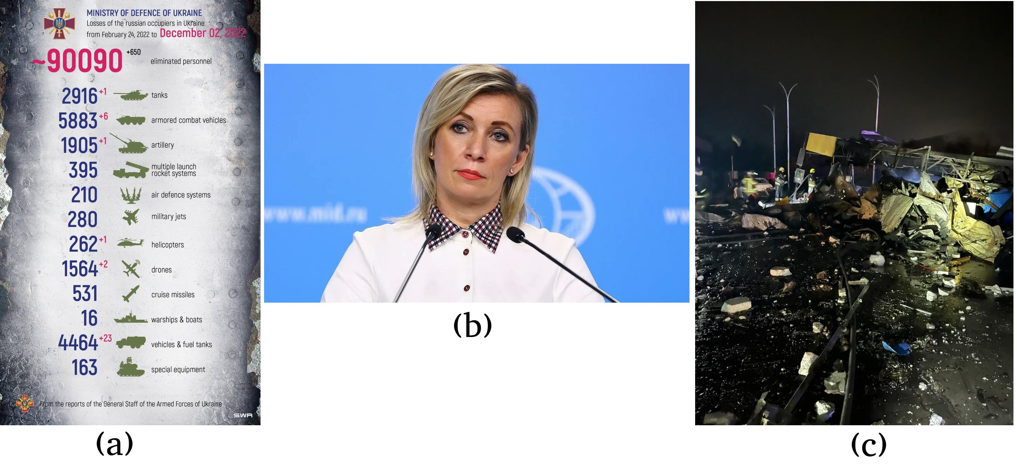

Figure 1: Examples of images in the final dataset. **(a)**: An information image shared daily by the Ministry of Defense of Ukraine. (b): A stock image of Russian Ministry of Foreign Affairs spokesperson, Maria Zakharova. (c): Aftermath of a missile attack.

Emojis not showing up – remember to check when using a different writing software

|  |  |
| --- | --- |
| **Author** | **Text** |
| armscontrol_rus | Over 28000 tons of military hardware supplied by the West to the Kiev regime, most of which is slipping to the black market. Europe's police authorities are alarmed. Does the 🇫🇷🇩🇪 initiative to combat illegal circulation of firearms in the Western Balkans living up its goals? |
| Denys_Shmyhal | During a telephone conversation with @Elisabeth_Borne thanked 🇫🇷 for comprehensive assistance, including #EU integration and countering russian aggression. Discussed unblocking grain exports, demining and 🇺🇦 recovery. Sure in our partner’s support! |
| UKRinUN | 100 days ago #Russia started a full-scale war on #Ukraine. 12M people had to flee their homes: 5M had to go abroad, and 7M became internally displaced people. #LifeWillPrevail #StandWithUkraine #StopRussianWar #ArmUkraineNow |

Table 1: Examples of text in the final dataset.



Figure 2: Distribution of the dataset over time.

|  |  |  |
| --- | --- | --- |
| **Account handle** | **Description of account** | **Number of tweets in dataset** |
| mfa_russia | Ministry of Foreign Affairs of Russia | 92 |
| mission_rf | Permanent Mission of Russia to the International Organizations in Vienna | 8 |
| armscontrol_rus | Russian Arms Control Delegation in Vienna | 34 |
| RusMission_EU | Permanent Mission of Russia to the EU | 4 |
| RussiaUN | Russian Mission to the UN in NY | 36 |
| RusEmbUSA | Russian Embassy in the USA | 39 |
| mission_russian | Russian Mission to the UN and other International Organizations in Geneva | 23 |
| RussianEmbassy | Russian Embassy in London | 196 |
| natomission_ru | Russian Mission to NATO | 1 |
| CoE_Russia | Russian Embassy to France | 32 |
| Dpol_un | Dmitry Polyanskiy, representative of Russia to the UN | 2 |
| MedvedevRussiaE | Dmitry Medvedev, deputy chair of the Security Council of Russia | 1 |
| **Total** |  | 468 |

Table 2: List of Russian accounts, their description, and number of tweets in the dataset.

|  |  |  |
| --- | --- | --- |
| **Account handle** | **Description of account** | **Number of tweets in dataset** |
| MFA_Ukraine | Ministry of Foreign Affairs of Ukraine | 102 |
| UKRinUN | Permanent Mission of Ukraine to the UN | 10 |
| Ukraine | Official account of Ukraine | 3 |
| DefenceU | Ministry of Defence of Ukraine | 222 |
| UKRintheUSA | Ukrainian Embassy in the USA | 9 |
| DmytroKuleba | Dmytro Kuleba, Minister of Foreign Affairs of Ukraine | 22 |
| oleksiireznikov | Oleksii Reznikov, Minister of Defence of Ukraine | 58 |
| SergiyKyslytsya | Sergiy Kyslystya, representative of Ukraine to the UN | 49 |
| Denys_Shmyhal | Denys Shmyhal, Prime Minister of Ukraine | 34 |
| OlegNikolenko_ | Oleg Nikolenko, spokesperson for the Ukrainian MFA | 2 |
| EmineDzheppar | Emine Dzheppar, First Deputy Minister of Foreign Affairs of Ukraine | 104 |
| ZelenskyyUa | Volodymyr Zelenskyy, president of Ukraine | 6 |
| **Total** |  | 621 |

Table 3: List of Ukrainian accounts, their description, and number of tweets in the dataset.

#### Annotation process

The annotation was done using Label Studio, a Python library (Tkachenko et al., 2020). The annotator was shown an image accompanied by text, and had to select the propaganda techniques they found in both the image and text. The process can be seen in Figure X. Unlike annotations in similar previous research (Dimitrov et al., 2021), the process was not iterated. Instead, the following approach was used. First, the relevancy of a datapoint was evaluated. If the tweet was found to be irrelevant to the Russo-Ukrainian war, it was labeled as *irrelevant*; no further labels were given, and the tweet was considered annotated. If the tweet was relevant, the labels found applicable to the image and text combination were chosen. The annotator did not have to select a particular section of the text for a label – while this has been done before (Martino et al., 2019), it ultimately provides data that was not found to be relevant to this thesis. Ideally, the text and images would be labeled separately, and the techniques found in them would be consolidated into a final label, as this allows for a clearer consideration of the propaganda techniques used; however, this was not done due to the aforementioned time concerns. While initially the tweets were presented in a random uniform fashion, some time into the annotation process a choice was made to instead label them in descending order by date, to have a more consistent distribution over time. Due to this, the final dataset consists of a number of tweets between June 1st and December 16th of 2022, as well as all of the tweets found in the raw dataset from December 17th onwards.

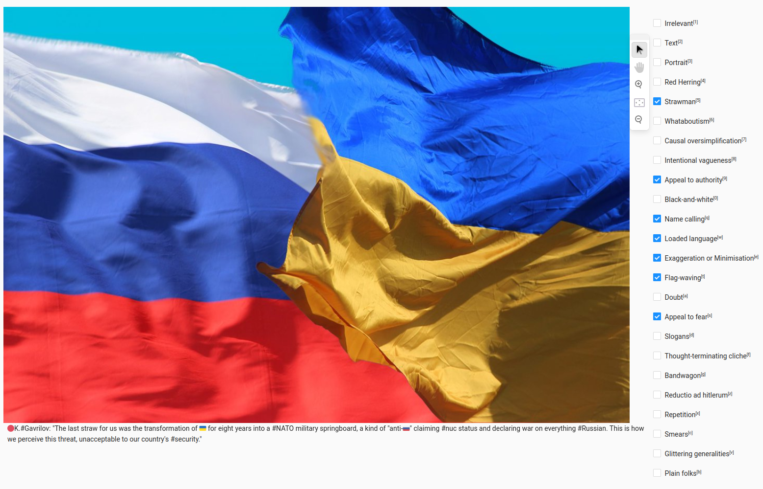

Figure 3: Example of the annotation process.

The annotation was done by a single person, the author of this thesis. Due to the sensitive and subjective nature of propaganda, this is not ideal; care should be taken when evaluating the annotated dataset, as there are inevitable biases in the labels and their distribution. However, no other arrangement could be found, and this is a limitation of the research that should be kept in mind during the analysis.

The annotation process presented some difficulties. First, it was not always obvious whether a tweet was relevant to the Russo-Ukrainian war. This is because, as noted in the analysis below, Russian accounts sometimes talked about topics such as the presence of the United States’ military in Europe, Russian citizen censorship in European countries, and the European Union’s policies. While the tweets did not mention Ukraine or the war by name, they talked about issues that were often either a result of the war, or cited as a cause for the war. As a rule, data points which were related to the U.S., Europe, the E.U., which were sometimes referred to as “the (collective) West” in the data, were treated as relevant to the war. However, if the tweet was clearly related to another geographical point, such as the U.S. involvement in Afghanistan, it was deemed irrelevant. This is also the case for the Ukrainian side: tweets which featured the military were deemed relevant to the war, even if they did not mention it, or Russia, by text.

Second, while most image or text repetitions were removed by not using retweets or replies during data collection, they still occurred in the raw data. If they were identical in both text and imagery to a previously seen datapoint, they were marked as *irrelevant*; there were 2 such cases. There were around 5 cases where two tweets had either the same image or text, but not both (excluding tweets using stock **Portraits**); tweets with the same text as a previous entry were marked as *irrelevant*, however, if they had the same image, but a different text, they were kept in the dataset. Finally, some tweets were part of a series, where a similar image was posted on a repeating schedule; these were labeled as normal in the dataset, but should be kept in mind, as they likely made the image classification easier for the models. Figure X (a) is an example of such an image.

The number of occurences for each propaganda technique can be seen in Table X. There was an average of 4.53 techniques per datapoint, with a maximum of 12 techniques labeled in one tweet (Figure X).

|  |  |
| --- | --- |
| **Propaganda technique** | **Number of occurrences** |
| Loaded language | 664 |
| Flag-waving | 648 |
| Smears | 609 |
| Appeal to authority | 479 |
| Slogans | 343 |
| Name calling | 336 |
| Glittering generalities | 330 |
| Plain folks | 315 |
| Appeal to fear | 171 |
| Repetition | 159 |
| Thought-terminating cliche | 148 |
| Exaggeration or minimisation | 141 |
| Strawman | 122 |
| Doubt | 92 |
| Intentional vagueness | 75 |
| Causal oversimplification | 68 |
| Black-and-white | 66 |
| Reductio ad hitlerum | 63 |
| Red Herring | 61 |
| Whataboutism | 44 |
| **Total** | **4934** |



# Computational background

#### BERT

BERT, or Bidirectional Encoder Representations of Transformers, is a state-of-the-art natural language processing (NLP) model. It is pre-trained on a large amount of sentences from books and the English Wikipedia (Devlin et al., 2019c). It was first proposed in 2019, and quickly became one of the most popular language models (at the time of writing, *bert-base-uncased* is the most popular text model on HuggingFace[1], a platform hosting machine learning models). At it’s core, BERT uses layers of *transformers*, which were described by Vaswani et al. (2017). A representation of transformer architecture can be seen in Figure X. While a full outline of the model is beyond the scope of this paper, a core feature that should be mentioned is the *self-attention* *layer*, which was used instead of at-the-time common *reccurent* and *convolutional* layers. Self-attention-based models differ from recurrent or convolutional neural networks by processing all of the data at once, instead of the sequential processing used in RNNs and CNNs. This allows the model to calculate *attention weights* between every input token, which are then used in downstream tasks, such as next token prediction or translation. For classification, a special token called [CLS] is created at the start of the sentence, and the weights of the token, also called the *hidden state*, are used to predict the final class. However, early transformer-based models were *unidirectional,* where every token could only have attention weights to previous tokens, not allowing them to gain information from tokens later in the sentence. BERT furthered the notion of transformers by performing bidirectional processing, processing all of the data both left-to-right and right-to-left at the same time (Devlin et al., 2019c). This allowed each token to gain context from both sides around it, making for a more powerful language model.

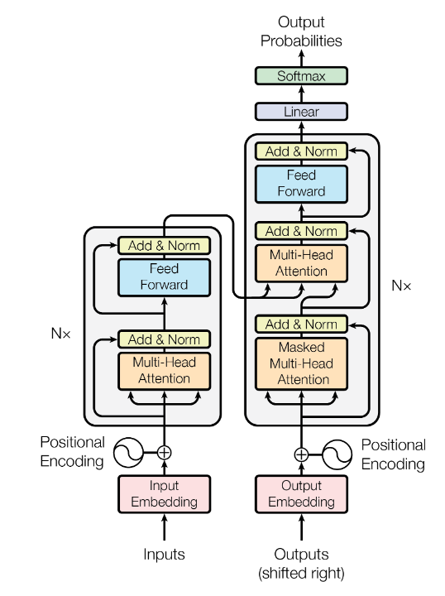

Figure 1: The Transformer model architecture (Vaswani et al., 2017).

#### Text and image features

To use text and images in machine learning models, they must first be converted into features that the model can understand. Text goes through two steps. First, the text is split into *tokens*; they do not correspond strictly to words, but the particular process of *tokenization* depends on the *tokenizer*. Since this experiment used BERT for text processing, the tokenizer associated with it was used. Tokenizers prepare the text for input by performing tasks such as padding the text to make the inputs even in length, adding tokens such as the mentioned [CLS] or the sentence-separating [SEP], and finally splitting the text into tokens. When the tokens are inputted into a model, they are converted into *features*, which are frequently called *embeddings* in text-based models. A graphical example of embeddings used in BERT can be seen in Figure X. The model uses three types of embeddings. Segment embeddings simply refer to the segment each token belongs to; in the example, there are two sentences (split by the [SEP] token), so each token belongs to segment A or B. Similarly, position segments show where in the text the token is, incrementing with each token. Token embeddings are what were earlier referred to as *features*. In BERT’s case, WordPiece (Wu et al., 2016) embeddings are used with a 30.000 token vocabulary (Devlin et al., 2019c). Each token is *embedded* into a vector of discrete numbers, representing various aspects of the token, which include both high-level concepts such as tenses for verbs, as well as low-level, language modeling concepts. The token embeddings used by BERT have 768 dimensions, and the final token representation is the sum of its token, segment, and position embeddings.

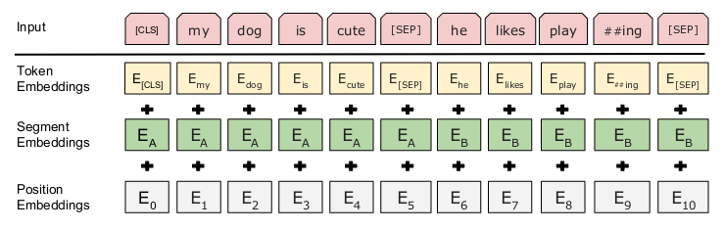

Figure 2: BERT input representation (Devlin et al., 2019c).

Images can be converted to different features depending on the model and task at hand. The MMBT model, described below, uses ResNet-152 (He et al., 2016), which essentially converts the image into features by passing the RGB values of each pixel through 152 layers of convolution (informally, *convolution* applies a function on the values of the pixel), where the model learns the weights to use for the convolutional kernels. Two other models described in a later section, ViLBERT and VisualBERT, use image regions instead. To do this, an image must first be segmented into regions. In the experiment, this is done by using Mask-RCNN (He et al., 2018), a convolutional neural network for image segmentation. An example of its usage can be seen in Figure X. This segmentation framework works in two steps: first, it finds objects in the image using convolutional kernels and binds them in a box; second, it segments the pixels within the box to a particular pre-defined category. In ViLBERT and VisualBERT, these objects are then converted to features by using convolutional neural networks, and used in a similar way to the token embeddings of BERT, described above. Feature-wise, the main difference between MMBT or later-fusion models, and ViLBERT or VisualBERT, is that the former convert the entire image into features, while the latter only use objects found within the image. Thus, they rely on there being “useful” objects within the image, but may produce better features as a result.

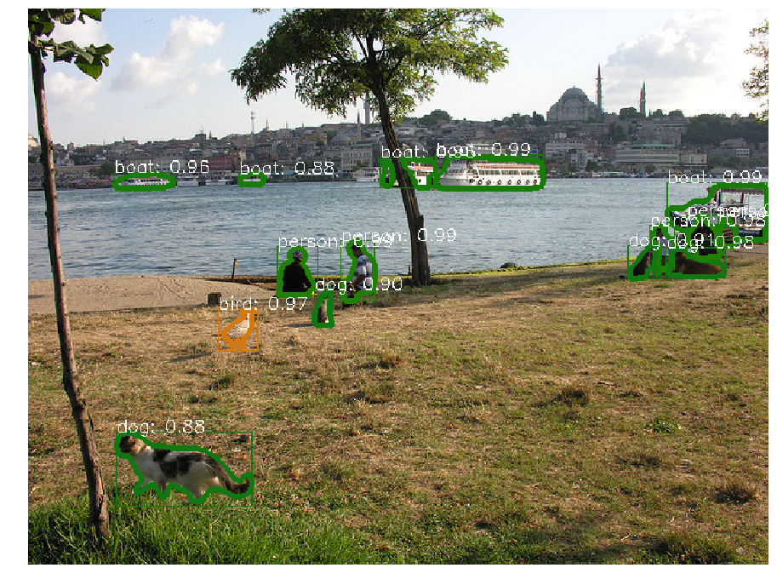

Figure 3: Image segmentation using Mask-RCNN (Massa & Girshick, 2018).

#### Multimodal fusion

Multiple modalities are incorporated into a single model by using multimodal fusion. Introducing multiple different modalities – either text and image, audio and visual, or any other – can provide data with more features, which leads to a better classification. There are two main methods of fusion: *early fusion* and *late fusion* (Atrey et al., 2010). Another variant, in literature called either *middle* or *hybrid* fusion, has recently been used to train multimodal models as well (Kiela, Bhooshan, et al., 2020). In this text, I will refer to the two modalities as text and image, however, the principles detailed here are generally applicable to a number of different modalities.

Early fusion (Figure X) refers to a setup where the features of text and image are combined into a single feature vector and passed to a learning model. This creates a truly multimodal representation – the data used at each training and evaluation cycle inherently contains both image and text representations. From a practical standpoint, the fact that there is only one feature vector means that only one training phase is required. However, there are some disadvantages as well. First, this method requires the two modalities – text and image – to be in the same dimension, which requires feature vector transformations. Since text is generally the more dominant modality in text-image approaches (Kiela, Bhooshan, et al., 2020), this is usually done by transforming the image representation into a textual one. Second, the model becomes less explainable – there is less certainty about the influence each modality has on the final classification (Atrey et al., 2010).

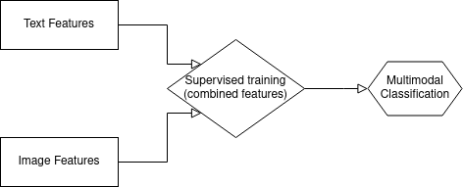

Late fusion (Figure X) is a simpler solution. Here, the two modalities are processed separately, using a different unimodal model for each. The classification outputs are then aggregated in some way - including averaged (Kiela, Bhooshan, et al., 2020), passed further into a Support Vector Machine (Atrey et al., 2010) or a ranking function (Ye et al., 2012) – to get the final classification output. The advantage of this approach is the fact that the two different unimodal models can be integrated easily, and the setup is very model-agnostic. It relies on the strengths of the individual models, which can prove to be more useful if the data is poor in one of the modalities. On the other hand, it requires multiple training phases, which generally leads to a longer training time. Further, it does not exploit the relations between the modalities in the data, which could lead to a lower performance in some cases.

Middle fusion (Figure X) is a hybrid version of these two options. Like in late fusion, the two modalities have their own separate models for training. However, after training is finished, the output layers of the models are then passed into a further model as input. For example, if using ResNet-152 for image classification, and BERT for text classification, the output of the second-to-last layer for the visual part - 2048 dimensions - and the output of the [CLS] token for the textual part - 768 dimensions - would be taken, for a total of 2816 dimensions (Dimitrov et al., 2021). These are then passed into a classification model, which is further trained to output a classification for each tweet. This leads to a model that can combine good individual encoders for each modality, and use their output layers, instead of predictions, to train and predict (Kiela, Bhooshan, et al., 2020). However, it runs into problems that both early and late fusion models face – it is less explainable, and requires at least three training phases.

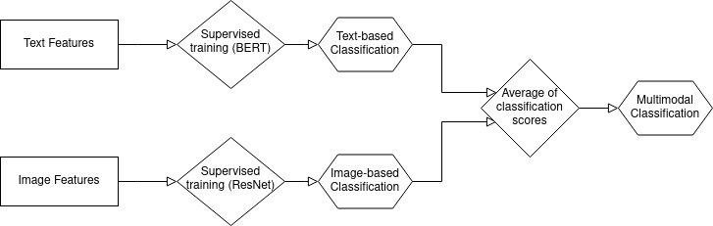

# Experiments

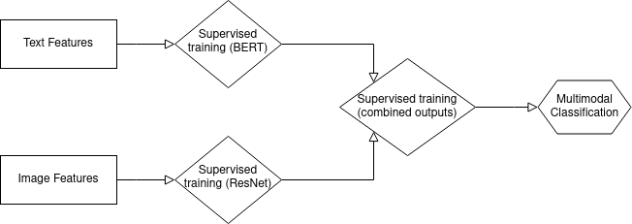

For the machine learning experiment, the labeled tweets were used in training and evaluating both unimodal and multimodal machine learning models for classification, i.e. given a tweet, predict all of the propaganda techniques that it contains, as labeled by the annotator. The experimental setup was similar to previous research on multimodal datasets (Dimitrov et al., 2021; Gundapu & Mamidi, 2022; Kiela, Bhooshan, et al., 2020). The MMF framework (Singh et al., 2020) was used to set up the models, their training and evaluation.

## Models

#### Baselines

Two baselines are used. First, a *random* baseline, which has a uniform chance of predicting each label. Second, a *majority class* baseline, which always, and only, predicts the biggest class in the corpus – *loaded language*.

#### Unimodal

To see how explanable the dataset is with only one modality, the text-based BERT (Devlin et al., 2019a) model was used for classification. Because the corpus in this paper comes from social media, while BERT is trained on Wikipedia and books, a mismatch in the data domains may lead to a decrease in overall performance (Plank, 2016), however, it should not influence model comparison.

#### Multimodal with unimodal pre-training

Three multimodal models pre-trained on unimodal data, based on the three versions of multimodal fusion detailed in section x, were used for the experiment. The MMBT model (Kiela, Bhooshan, et al., 2020) was used as an early fusion model. It consists of ResNet-152 (He et al., 2016), pre-trained on the large-scale image database ImageNet (Deng et al., 2009), which transforms the images into a representation suitable for BERT, which is pre-trained as in the unimodal version, and takes the transformed image embeddings, as well as the text embeddings, as input to produce a classification. With high-quality multimodal data, it has been shown to outperform other unimodal, as well as middle- and late-fusion models (Kiela, Bhooshan, et al., 2020). The same two unimodally pre-trained models, ResNet-152 and BERT, are used for middle as well as late fusions. For the late fusion model, the average of the predictions of the two models was used.

#### Multimodal with multimodal pre-training

The models in the previous section were multimodal, but they were pre-trained using unimodal data – separate textual and visual datasets. For further diversity, this paper includes two models which have been pre-trained on multimodal data. Vision-and-Language BERT (ViLBERT) (Lu et al., 2019) uses two streams, one for each modality, interacting through co-attentional transformer layers, to process the data. For pre-training, it uses the Conceptual Captions dataset (Sharma et al., 2018), which consists of around 3 million images with cleaned alt text, gathered from a variety of websites. In the architecture, the two streams are initialized with modality-specific weights: the text stream, as in previous models, is instantiated with pre-trained BERT weights; the image stream uses Faster R-CNN (Ren et al., 2015) with a ResNet-101 backbone, which is pre-trained on the Visual Genome dataset (Krishna et al., 2016) for its weights. The model is pre-trained on five different image-text tasks, though none of them are classification tasks. However, ViLBERT is presented as a task-agnostic model, and it has reached good results in similar tasks (Dimitrov et al., 2021; Gundapu & Mamidi, 2022).

Another multimodally pre-trained model used is VisualBERT (Li et al., 2019). While developed concurrently with ViLBERT, it uses a different architecture and pre-training dataset. Instead of a stream for each modality, as in ViLBERT, it has only one BERT-based stream, as in a traditional early fusion model. To accomodate both images and text, images are transformed into visual embeddings by using visual features of bounded regions. They are then concatenated to word embeddings and passed into the model. The transformer uses self-attention to train, unlike the co-attentive implementation of ViLBERT. VisualBERT is pre-trained on COCO (Chen et al., 2015), a dataset of over 300 thousand images, each having 5 human generated captions. VisualBERT was tested on four different datasets, though they do not focus on classification either. Li et al. (2019) show that VisualBERT is a competitive multimodal modal, and it outperforms ViLBERT on 1 of the 2 datasets they were both tested on.

Both ViLBERT and VisualBERT use image regions to extract features from images and transform these into embeddings that they can use. For the dataset described in this paper, the Mask-RCNN (Massa & Girshick, 2018) neural network was used to extract image regions.

## Metrics

The F1 micro and macro scores were used for evaluation during the experiments. The F1 score is defined as

$$F_{1}=\frac{2 * TP}{2 * TP + FP + FN}$$

where *TP* is *true positive* – number of labels that were correctly classified as existing for a datapoint, *FP* is *false positive* – number of labels that were incorrectly classified as existing for a datapoint, and *FN* is *false negative* – number of labels that were incorrectly classified as not existing for a datapoint (Taha & Hanbury, 2015). *F1 micro* refers to a version of the score where the F1 score is calculated for all of the labels at the same time. On the other hand, *F1 macro* refers to a version where the F1 score is calculated for each label individually, and the arithmetic mean of these scores is taken as the final result. Since F1 scores are applicable to multilabel classification, they are often used as a performance metric for setups such as in this paper. In the experiment, the F1 micro score is used for *early stopping* during training (stopping the training of the model if it does not improve), and both types of F1 scores are reported for every model.

## Data setup

The data was split into training, validation, and testing data, with 762 (60%), 82 (10%), and 245 (30%) examples, respectively. Figure X shows the distribution of the labels among the splits. The sizes of the splits were motivated by existing multimodal datasets. At first, a split of 72% / 7% / 21% was used, as used in the Propaganda in Memes dataset of propagandist memes and the text they contain (Dimitrov et al., 2021). However, during early experimentation, it was found that the training algorithm never predicted some of the labels during the validation phase, which lead to warnings and uninformative F1 macro scores. To alleviate this, the distribution of 60% / 10% / 30% was chosen instead, hoping that the increase in validation data would allow the models to learn enough to predict the labels with the fewest examples. This split can be seen in other multimodal datasets, such as the MM-IMDB dataset of descriptions of films and their posters (Arevalo et al., 2017). While this did not stop the problem, the split was kept for the full experiment.

## Training setup

To select the best hyper-parameters, the models were run on the validation data. The hyper-parameters to test were chosen from previous research on the models used (Devlin et al., 2019b; Dimitrov et al., 2021; Kiela, Bhooshan, et al., 2020; Li et al., 2019; Lu et al., 2019). The learning rate was tested over {1e-4, 5e-5}, batch size: {32, 64, 256, 512}, number of epochs: {34, 170, 340}. The following setup was chosen:

* Batch size
  + BERT, ViLBERT: 64
  + Others: 32
* Optimizer: AdamW
  + Learning rate: 5e-5
  + Epsilon: 1e-8
  + Weight decay: 0.01
* Max sequence length: 128
* Number of epochs
  + BERT, ViLBERT: 340
  + Others: 170
* Early stopping: F1 micro on the validation set.

The models were trained on 4 NVIDIA Quadro RTX 8000 GPUs, courtesy of Center for Humanities Computing, Aarhus University. BERT took 15 minutes to train and evaluate on average; the other models took around 25 minutes. All reported results are averaged over three runs with random seeds.

|  |  |  |  |  |  |  |  |  |  |  |  |  |  |  |  |  |  |  |  |  |
| --- | --- | --- | --- | --- | --- | --- | --- | --- | --- | --- | --- | --- | --- | --- | --- | --- | --- | --- | --- | --- |
|  | Loaded language | Flag-waving | Smears | Appeal to authority | Slogans | Name calling | Glittering generalities | Plain folks | Appeal to fear | Repetition | Thought-terminating cliche | Exaggeration or minimisation | Strawman | Doubt | Intentional vagueness | Causal oversimplification | Red Herring | Black-and-white | Reductio ad hitlerum | Whataboutism |
| Train | 390 | 388 | 356 | 290 | 212 | 198 | 195 | 187 | 102 | 95 | 90 | 87 | 63 | 55 | 51 | 42 | 37 | 36 | 33 | 21 |
| Val | 65 | 70 | 58 | 52 | 47 | 30 | 33 | 30 | 17 | 18 | 17 | 15 | 14 | 8 | 7 | 7 | 6 | 6 | 6 | 4 |
| Test | 209 | 190 | 193 | 137 | 84 | 108 | 102 | 98 | 52 | 46 | 41 | 39 | 45 | 29 | 17 | 19 | 18 | 24 | 24 | 19 |

# Experiment results

The results of the experiment can be seen in Table X. The baseline model results are on rows 1-2; they show that the random class outperforms the majority, especially in the F1 macro score. Row 3 shows the results for BERT, which, as expected, outperforms the the baselines. Rows 4-6 are various versions of the BERT + ResNet-152 fusion. While none of them outperform BERT, they seem to keep improving as the fusion is applied later in the pipeline. Finally, rows 7-8 show results for the two multimodally pre-trained models. Surprisingly, they performed poorly, with neither outperforming the random baseline.

Overall, the best performing model was BERT. This is an interesting result, as BERT only uses one modality of the two found in the corpus. This suggests that the images are not informative, and may in fact be detrimental for good classification. This is supported by the other results. In the unimodally pre-trained fusions, it is found that late fusion outperforms early and middle fusions. This suggests that having the two models, BERT and ResNet-152, fuse earlier in the architecture is detrimental to classification. This is likely due to the image model performing poorly, which is mitigated in late fusion by averaging it with the well-performing BERT.

ViLBERT and VisualBERT, on the other hand, perform worse than all of the other models (except for the majority class baseline). This is unprecedented in literature; they are usually among the best performing models (Dimitrov et al., 2021; Gundapu & Mamidi, 2022; Kiela, Bhooshan, et al., 2020). This could be due to poor region extractions from the images, as these were the only two models to use them. Image segmentation was done using default parameters, which might not have been ideal; furthermore, the images themselves could be either uninformative, containing generic objects or text, or hard to segment. [mention number of portraits / text here]

For comparison, Gundapu and Mamidi (2022), using the Propaganda in Memes dataset, report that RoBERTa (Liu et al., 2019), a model similar to BERT, outperformed ViLBERT, VisualBERT, as well as a simple early fusion model; however, it performed worse than some middle or late fusion models. This is relatively consistent with the results of this paper, and they observe the same ideas with regards to images, in that they may not convey any meaningful information due to the nature of the data, which would explain the results. On the other hand, Dimitrov et al. (2021), on the same dataset, observed very different results: in their case, ViLBERT and VisualBERT were the best-performing models, while early fusion outperformed late fusion. The two papers report very different F1 scores as well, with the former providing scores that are bigger by 10 or 15 for all models, even the ones implemented in the same way. It would be interesting to establish why that is the case; however, Gundapu and Mamidi (2022) did not provide access to their code.

Another interesting thing to note are the F1 macro scores. BERT exhibited a similar F1 micro score for both my dataset, as well as the one proposed by Dimitrov et al. (2021), where it outperformed by 0.38. However, BERT reported a F1 macro score that is over 10 points higher for the Twitter dataset (26.90 vs 15.62). While generally F1 scores are not comparable between tasks, since they depend on the distribution and type of the corpus (Derczynski, 2016), the two datasets have a comparable size (950 and 1089 datapoints), are used to classify the same thing (propaganda), and are both quite skewed (2.80 Shannon entropy for my corpus compared to 2.42 for theirs), which makes the F1 scores comparable. This huge difference in the macro scores suggests that BERT could classify the labels with a small representation better in my data. This may be due to the generally higher number of labels in this dataset (average of 4.53 per tweet, compared to an average of 2.61 for the Propaganda in Memes dataset), which leads to a bigger absolute number of the least represented labels, allowing the models to learn them better. Another consideration is that the data is less diverse – particular labels may be applied to specific, similar types of tweets, such as the ones that repeat daily, leading to a good performance for classifying tweets into these labels, since the features in the images and text are likely to be similar.

|  |  |  |  |  |
| --- | --- | --- | --- | --- |
| **Type** | **#** | **Model** | **F1 micro score** | **F1 macro score** |
| Baseline | 1 | Majority class | 22.95 | 3.90 |
| 2 | Random | 30.92 | 26.62 |
| Unimodal | 3 | BERT | **37.33** | **26.90** |
| Multimodal with unimodal pre-training | 4 | MMBT (early) | 30.91 | 15.98 |
| 5 | BERT + ResNet-152 (middle) | 34.66 | 20.63 |
| 6 | BERT + ResNet-152 (late) | 34.96 | 22.34 |
| Multimodal with multimodal pre-training | 7 | ViLBERT | 28.73 | 17.14 |
| 8 | Visual BERT | 30.68 | 16.60 |

Table 4: Results of the experiment.

# Statistical analysis

#### Comparison of Ukrainian and Russian data

As a first step in conducting a more thorough analysis on the data, the Russian and Ukrainian populations were compared. To do this, a statistical analysis on the means of the use of propaganda techniques in the two populations was done. Because each account had a different number of tweets, the frequencies of the labels were normalized to [0-1]. For example, *CoE_Russia* used *Appeal to authority* in 22 of their 32 tweets - this was normalized to a frequency of 0.6875. Accounts with less than 10 tweets were excluded from the statistical analysis to make it more robust. Welch’s unequal variance t-test (Welch, 1947) was used as the analysis tool, as the two populations were independent, had normal distributions, but the potential underlying differences in sample sizes (number of tweets) and variance made the Student’s t-test an undesirable option (Ruxton, 2006). Significant (p < 0.05) differences in the means of the use of propaganda techniques can be seen in Table X.

As can be seen, over half of the techniques had a significantly different frequency of use. Three techniques – *flag waving, glittering generalities*, and *slogans* – were more commonly used by Ukrainian accounts; the rest were more commonly found in Russian tweets.

|  |  |  |  |
| --- | --- | --- | --- |
| **Technique** | **T** | **Degrees of freedom** | **p-value** |
| Appeal to fear | 2.46 | 10.30 | 0.033 |
| Causal oversimplification | 4.86 | 6.36 | 0.002 |
| Doubt | 6.05 | 11.91 | 0.00006 |
| Flag-waving | -2.98 | 8.81 | 0.016 |
| Glittering generalities | -4.31 | 6.30 | 0.004 |
| Intentional vagueness | 3.01 | 11.90 | 0.01 |
| Loaded language | 2.63 | 10.06 | 0.025 |
| Red Herring | 2.42 | 11.93 | 0.03 |
| Slogans | -3.30 | 7.45 | 0.01 |
| Smears | 5.44 | 6.33 | 0.001 |
| Strawman | 6.35 | 7.37 | 0.0003 |
| Whataboutism | 3.31 | 8.75 | 0.009 |

Table 5: Welch's t-tests on the propaganda techniques used in Russian and Ukrainian data. Negative T values note that the propaganda technique was used significantly more in Ukrainian tweets; positive values note a significant usage by Russian accounts.

Furthermore, natural language analysis on the text in the corpus was conducted. To do this, the TextDescriptives Python package (Hansen et al., 2023) was used. The package provides easy access to a variety of of natural language metrics, such as readability, coherence, quality, as well as some descriptive statistics such as a comparison on the length of texts or the Parts-Of-Speech (POS) used in the texts. All of the metrics available were applied to the entire corpus, which was then correlated with the texts belonging to particular accounts. For converting the words into tokens, the spaCy (Honnibal et al., 2020) model *en_core_web_lg* was used.

In general, there were no strong correlations for any metric and the text belonging to either a Russian or Ukrainian tweet; this is not unexpected, as the data comes from the same domain, and was written with similar intentions. However, some weak correlations were found. Correlations were calculated using Spearman’s correlation statistic, which first ranks each variable, and then computes the correlations between them. This makes it less sensitive to outliers, which makes it useful for the texts, as they might be very different in their content. Spearman’s correlation can be defined as:

$$r = 1 - \frac{6\sum{d_{i}^{2}}}{n(n^{2}-1)},$$

Where *di = R(Xi) – R(Yi)* is the difference between the two ranks of each observation, and *n* is the number of observations.

Figure X shows graphs of the most interesting correlations. The strongest correlation (r = 0.35, p < 0.001) was between the text having a Ukrainian origin and having a higher hashtag frequency. This was followed by correlations on the readability of the text. The Gunning-Fog Index (Gunning, 1969), Flesch-Kincaid grade (Tanprasert & Kauchak, 2021) and Rix (Anderson, 1983) all showed that Ukrainian texts were harder to read or understand. Figure X shows the plot for Rix (r = 0.31, p < 0.001), which is calculated as

$$Rix = \frac{number of long words}{number of sentences},$$

Where a word is long if it contains more than six characters. Finally, a weak correlation (r = 0.30, p < 0.001) was found between the text coming from a Ukrainian account and the sentences being longer.



#### Comparison of organization and individual data

Similar approaches were applied on the organization – individual level as well. Because there were no Russian individuals with over ten tweets in the corpus, and a simple comparison of the entire corpus might be influenced by differences in Russian and Ukrainian data, only the Ukrainian tweets were used for this comparison. Results for Welch’s t-tests on the mean frequencies of propaganda technique usage for Ukrainian individuals and organizations can be seen in Table X. *Causal oversimplification* was used significantly more by organizations; *repetition* and *slogans* had a higher individual usage.

|  |  |  |  |
| --- | --- | --- | --- |
| **Technique** | **T** | **Degrees of freedom** | **p-value** |
| Causal oversimplification | -2.83 | 4.99 | 0.04 |
| Repetition | 3.65 | 3.36 | 0.03 |
| Slogans | 3.54 | 4.84 | 0.02 |

TextDescriptive metrics were applied to this data as well. Interestingly, the correlations were stronger on the organization-individual level than on the Russian-Ukrainian level. Notable differences can be seen in Figure X. *Rix* appears again (r = 0.35, p < 0.001), showing that texts coming from organizations were harder to parse than those coming from individuals. A stronger correlation was the number of characters per text (r = 0.57, p < 0.001), where the tweets from organizations have a notable spike at around 230 characters, while individual texts seem to have a slowly increasing distribution from 50 to 250 characters. Finally, a weak correlation was found between a tweet coming from an individual and having a higher *per word perplexity* (r = -0.35, p < 0.001). Per word perplexity is the length normalized perplexity of the text, defined as:

$$Per Word Perplexity=\frac{ e^{-H(X)}}{number of words},$$

Where *X* is the sample text, and *H(X)* is the Shannon entropy of the text, defined as:

$$H\left(X\right)= - \sum_{i=1}^{n}{p\left(x_{i}\right)\log_{e}p(x_{i})},$$

Where *p(xi)* is the probability of each token in the text. Entropy defines the expected amount of information conveyed by the text (Shannon, 1948). Informally, per word perplexity shows how easy it is to predict the next word by using a language model. A higher perplexity means that the corpus is harder to model (Kłosowski, 2018). While generally used to compare language models, perplexity can also show which corpus is harder to predict using the same model. In this case, texts from individuals have less certainty. This may be due to harder words, or words that do not appear in the corpus.



#### The influence of technique usage on tweet visibility

Another interesting aspect is estimating which propaganda techniques are useful to use. This can be evaluated by using Twitter impressions, which were collected along with the rest of the data. An impression on Twitter is a single view of a tweet. To estimate which techniques boost a tweet’s visibility, two evaluations were done. They both rely on the same principle: predicting the impressions of a tweet based on the propaganda techniques used in the tweet. Because the accounts in the corpus all have different popularities, each tweet’s impression count was compared to the median impression count of its author, and a binary variable, noting whether the tweet was more or less visible than the median tweet of the author, was created. This variable is called the *impression class* in the rest of this section. The techniques used were encoded as binary values in the set {0, 1}, where 0 denotes that the technique is not used in a tweet, while 1 notes its usage within a tweet. Some tweets in the corpus had 0 impressions – this was likely a bug in data collection, so they were excluded.

The first method uses ANOVA F-values (Ding et al., 2014) to calculate the importance of features. This is usually done in feature selection, where the unimportant features are discarded, while the important features are used in modeling a classification or regression model. The implementation used - the *f_classification* function of the scikit-learn Python package (Pedregosa et al., 2011) – computes the following F score for each propaganda technique:

$$F = \frac{ρ^{2}}{1-ρ^{2}} * (n-2),$$

Where *ρ* is the correlation between the technique usage and the target (impression class), and *n* is the number of samples (tweets). A higher F value indicates a more important feature. The features that were significantly important (p < 0.05) as calculated by the F-values can be seen in Table X.

There are limitations to this approach. First, the F-values are computed independently for each technique. This means that the mutual information that could be gained from evaluating combinations of features is lost. Second, F-values can only tell the statistical importance of a feature, however, they do not quantify whether the feature is “good” or “bad”. Indeed, such a quantification would not be necessary for feature selection in a classification model. However, to see whether the techniques used improved the impression count or not, an additional approach was needed.

To this end, a simple logistic regression model (explain what it is?) was fitted on the data, and the coefficients of the features were extracted. The coefficients can be seen in Table X. A positive coefficient implies that the use of that technique corresponds with an increase over the average impression count. A negative coefficient implies a decrease. An issue with this approach is the simplicity of the model.

When testing binary classification models, two common metrics are used: the M*ean Squared Error (MSE)* and the *Area Under the ROC Curve (AUC)*. The Mean Squared Error is defined as:

$$MSE = \frac{1}{n}\sum_{i=1}^{n}{{(Y_{i}-{\hat{Y }}_{i})}^{2}},$$

Where n is the number of predictions, *Yi* is prediction *i*, and ${\hat{Y }}_{i}$ is the true label of sample *i*. It is a simple and often used way of evaluating a classifier’s accuracy (Wang & Bovik, 2009). The Area Under the Receiver Operating Characteristic Curve (AUC) is calculated by measuring the area under a ROC curve, which plots the *True Positive Rate (*defined as $\frac{positives correctly identified}{total positives}$) of the model on the *y* axis and the *False Positive Rate* (defined as $\frac{negatives incorrectly classified}{total negatives}$*)* on the *x* axis (Huang & Ling, 2005). It is another measure often used to evaluate binary classificators. Informally, an AUC of 1 shows a perfect classification algorithm, an AUC of 0 shows an algorithm that is always wrong, and an AUC of 0.5 implies that the algorithm performs like a random classifier.

When testing the logistic regression model, the following measurements were retrieved: *MSE: 0.5, AUC: 0.5.* These results essentially show that the algorithm is not better than a random classifier, and raise questions about the use of the models’ coefficients in the interpretation of the results.

|  |  |  |  |
| --- | --- | --- | --- |
| **Propaganda technique** | **F-value** | **P-value** | **coefficient** |
| Repetition | 8.49 | 0.004 | -0.85 |
| Plain folks | 4.17 | 0.04 | 0.29 |

Because of this, a second approach was considered. InterpretML (Nori et al., 2019), a Python package for machine learning interpretability, was used. The package includes the Explainable Boosting Machine (EBM), a state-of-the-art generalized additive model (GAM) (Hastie & Tibshirani, 1987) that has interpretable parameters. GAMs take the form:

$$g\left(E\left[y\right]\right)=β_{0} + \sum{f_{j}(x_{j})} ,$$

Where *β0* is the intercept, *xj* is feature *j*, *fj* is the feature function associated with it, *E[y]* is the target value applied with an exponential family distribution (for example, the normal distribution), and *g* is a link function specific to the task at hand (in this paper – binary classification). The model is trained to learn feature functions *f* such that *y* is predicted better. Unlike usual GAMs, EBM is fully interpretable (called a “glassbox” by the package), which made it a good candidate for the task. Instead of coefficients, an EBM model has *term scores*, which show how much each feature adds to or subtracts from the final prediction. Because of the nature of GAMs – the result being the addition of function values – the model can clearly show how the feature being present or not influences the prediction. The model also provides *term importances*, which can be interpreted similarly to the F-values above. However, unlike F-values, EBM also gauges feature combinations, allowing a higher power of interpretation.

EBM was fitted and tested with the same data as the linear regression model. It should be noted that the EBM model does not have a way of calculating significance; a method of measuring p-values for feature importance is in progress at the time of writing this paper[2]. This is the main weakness of the approach. Because it is unclear how many of the features used are significantly important, the five most important features are presented in Table X. The scores section shows the output of the relevant technique’s function based on if the technique is used in the tweet. For example, if there is no *repetition* in a tweet, it is slightly more likely to be viewed than the median (+0.09). However, if *repetition* is used in a tweet, the average impression decreases significantly more (-0.53).

|  |  |  |
| --- | --- | --- |
| **Propaganda technique** | **Importance** | **Scores** |
| Repetition | 0.152 | [0.09, -0.53] |
| Plain folks | 0.100 | [-0.06, 0.17] |
| Exaggeration or Minimisation | 0.091 | [0.05, -0.38] |
| Thought-terminating cliche | 0.077 | [-0.04, 0.32] |
| Appeal to authority | 0.073 | [0.06, -0.08] |

Slightly surprisingly, the EBM model had a similar performance to the linear regression model (*MSE = 0.53, ROC AUC = 0.48).* In general, both of the models performed poorly on the test set – they are either equal or slightly worse than a random binary classifier. This is partly explainable by the task – the means of the impression counts had big standard deviations, as the tweets were very varied in their impression counts even within the same account. This in turn makes them hard to predict. It could also be the case that the propaganda techniques used are bad or unimportant predictors – there are a lot of external factors, such as the time of day of the tweet, whether it was retweeted by popular accounts, whether it showed up in the *Trending* page on Twitter, that are not considered here. Finally, the manual labeling done might not be consistent, which would make the classification harder. However, if these nuances are kept in mind, the feature importances can still be considered in the data analysis.

# Narratives (case studies? Discussion?)

#### Irrelevant data

[might want to move this to the methods section]

To gain insight into why over a third of the collected data was not useful to the paper, a study of the irrelevant data was conducted. The distribution of irrelevant data over the accounts in the corpus can be seen in Figure X. As can be seen, irrelevant tweets came primarily from Russian accounts, and around half of the datapoints came from two accounts – *mfa_russia* and *RussiaUN*. Examples of posts from these accounts, as well as one from an Ukrainian account, can be seen in Figure X. Because the corpus of accounts consists primarily of embassies, missions to other countries, and diplomats, irrelevant texts are often related to visits or discussions on countries other than Ukraine or Russia.

However, whether or not a tweet is classified as relevant depends on the context and use of words as well. For example, Figure X (c) shows a tweet from the Ukrainian minister of foreign affairs, Dmytro Kuleba. It was labeled as irrelevant, as it did not make mention or reference to the war, though it did speak of a *historic visit*, *cooperation*, and V. Zelenskyy is pictured in the military fatigues he has worn since the invasion began. In general, it speaks of a discussion between Ukrainian and Guatemalan diplomats. A tweet with a similar premise was posted when D. Kuleba met with the UN commissioner for refugees: *“Today, @FilippoGrandi and I discussed UNHCR's humanitarian aid, protection of Ukrainian citizens and children. We focused on our plans, including cooperation in comprehensive capacity building of @MFA_Ukraine infrastructure needed to protect and assist Ukrainian citizens abroad. ”* This post, however, was labeled as relevant (with labels *appeal to authority, glittering generalities, plain folks*), because of the words *humanitarian aid, protection of Ukrainian citizens and children*. It is possible that the topic of war or aid was brought up with the Guatemalan diplomats as well, but as it is not described in the tweet, it was not included in the corpus.

The fact that over 87% of the irrelevant tweets came from Russian accounts is quite interesting. One explanation for this is that Russia is a more important state in international politics: it is a permanent member of the United Nations Security Council and a leading member of international organizations in Europe and Asia. Thus, a lot of the irrelevant tweets are about Asia or Africa, as well as topics concerning the organizations Russia is in. On the other hand, many of the meetings diplomats from Ukraine hold are with European representatives, who have a bigger stake in the war. Furthermore, the fact that the war takes place almost entirely in Ukraine means that it is affected a lot more; in May of 2022, it was estimated that in the first year of the war, the Ukrainian economy would shrink by 30%, while Russia’s GDP would be reduced by 10% (Liadze et al., 2022). Because of this, almost every meeting between Ukrainian representatives and diplomats from other countries has war as one of its topics, while Russian diplomats seem to discuss other topics more often.

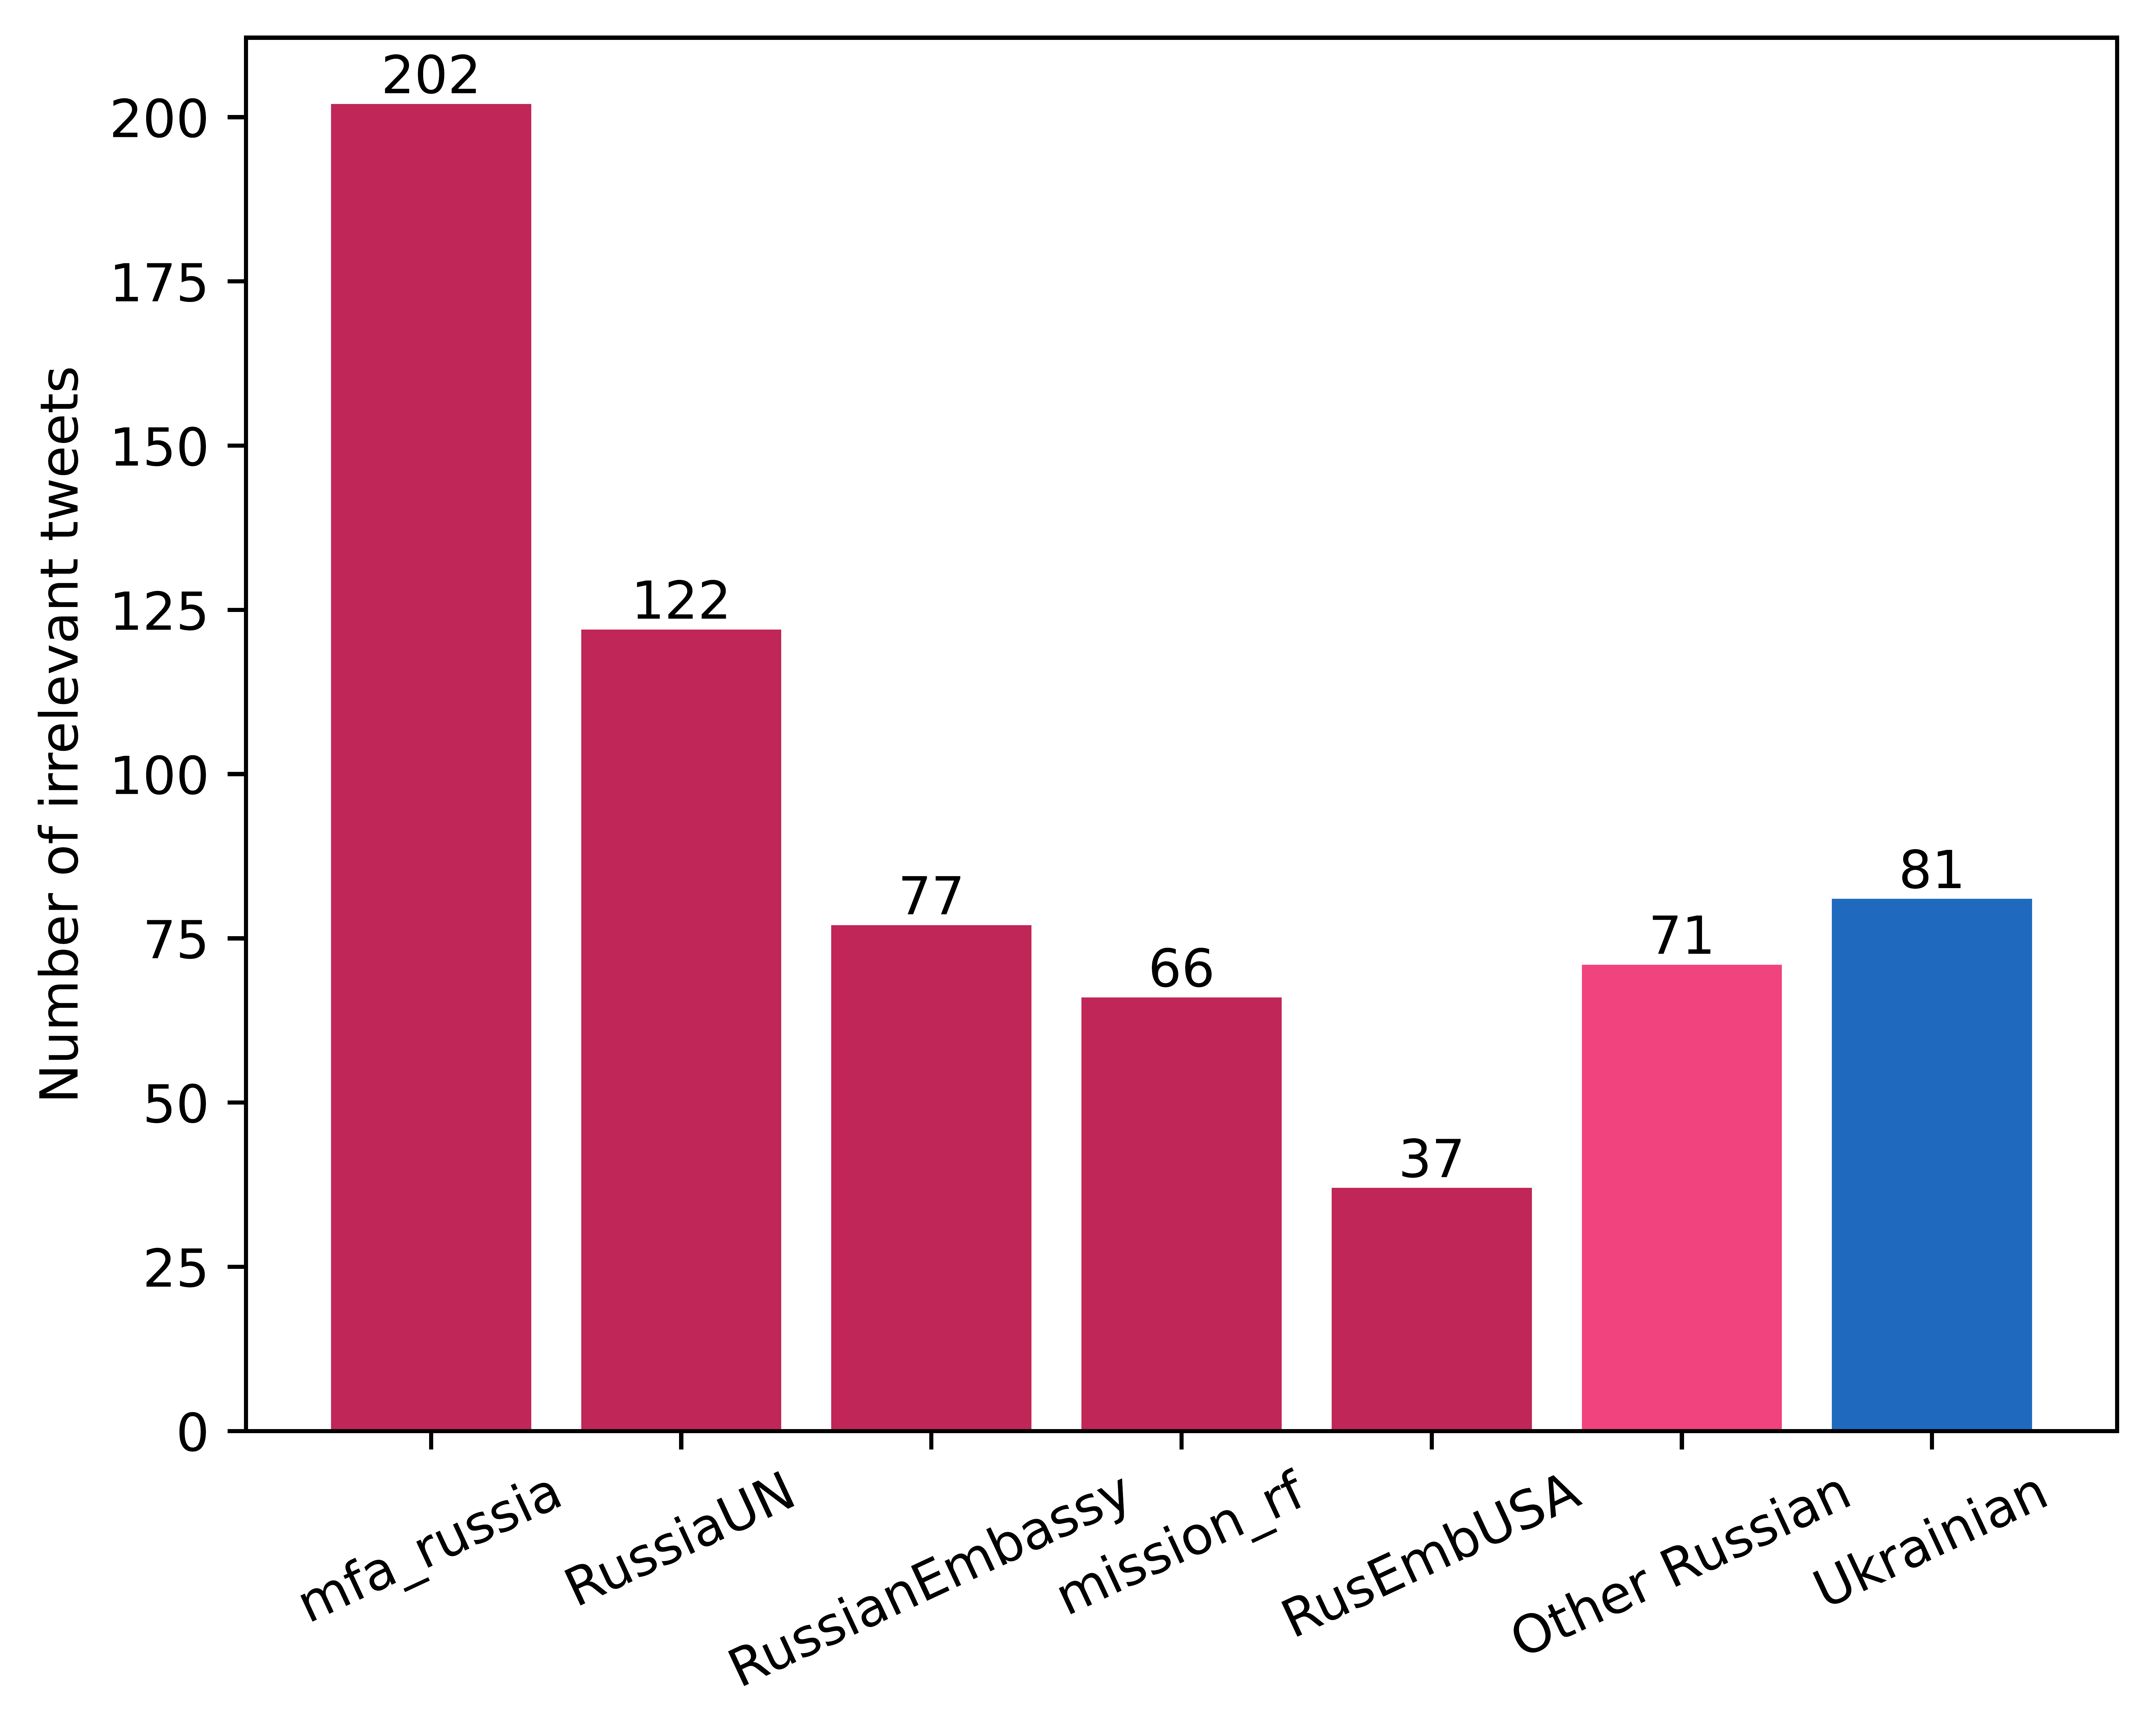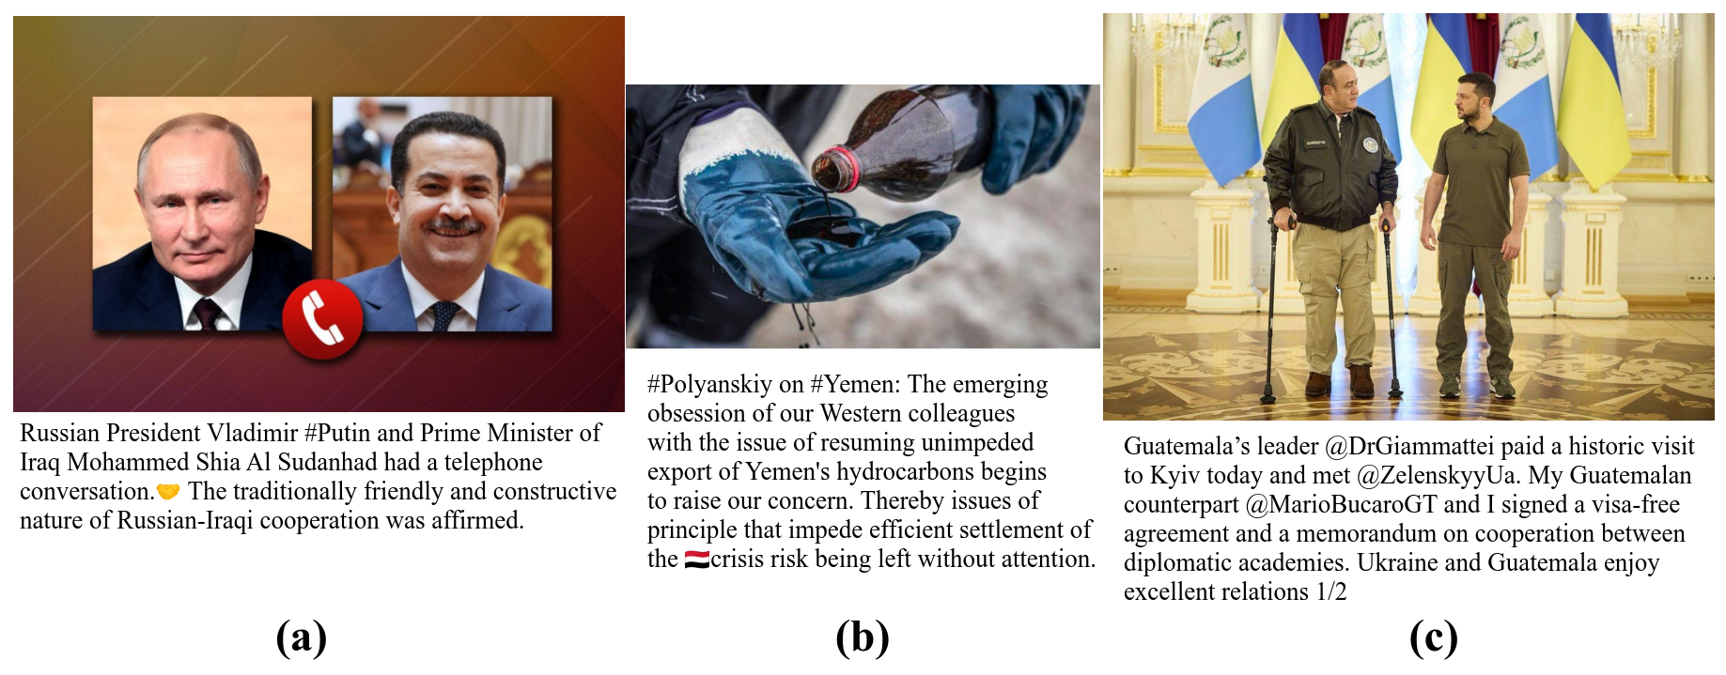

Figure 4: Examples of irrelevant tweets. Authors: (a) mfa_russia, (b) RussiaUN, (c) DmytroKuleba.

#### Portraits and text

The use of portraits by account can be seen in Figure X. As can be seen, about 40% of portraits in the corpus come from *RussianEmbassy*, and portraits constitute about 77% of this user’s images. This could imply that using stock portraits is not a universal strategy, with some accounts choosing to use them the majority of time, while others may use other stock imagery for quotes from authorities (Figure X (b)). It could be argued that there is no need to include portraits of quoted people, since the message of the tweet is contained entirely within the text, and the text generally mentions the author by name. However, stock portrait images still serve the target with visual *appeal to authority,* and in this way are no different to World War 2 era posters of Churchill or Hitler (Figure X). From a more practical point of view, 97% of Twitter users focus on visuals on the website (Dorney, n.d.), which makes images almost a requirement to send a strong message. On the other hand, Dorney (n.d.) also states that stock images should not be used, as they do not differentiate from other user’s posts. In the case of this corpus, stock images generally make *the user’s* tweets repetitive and similar to each other, and can reduce the visibility of a post on social media. Looking at the corpus of *RussianEmbassy*, stock images are generally used for comments made by politicians during press conferences, which are generally held in the same place, have the same background, and thus do not differ much day-to-day. This explains why stock portraits are used – unique portraits would not differ by much either way - but ignores the impact good social media usage could make.

Use of text in images by accounts can be seen in Figure X. As can be seen, text is not used as often as portraits. The biggest user of text in images, *DefenceU*, uses it in daily updates on the number of Russian military losses (Figure X (a)); 46 of 59 uses of *text* in their images come from these updates. In general, the use of text is likely due to the same reasons of using stock photos – it provides the tweet with visualization, which is useful for posts on social media when there is no actual content to be used as images. However, while stock photos may invoke a sense of authority, text in images can generally only reiterate what the text of the post already said. This is generally not a positive thing, as seen in section *Social Media.*

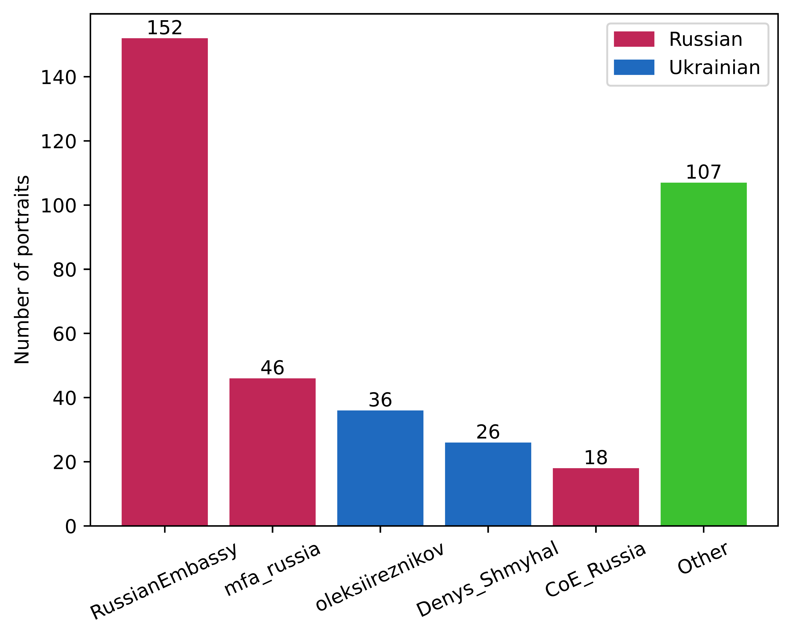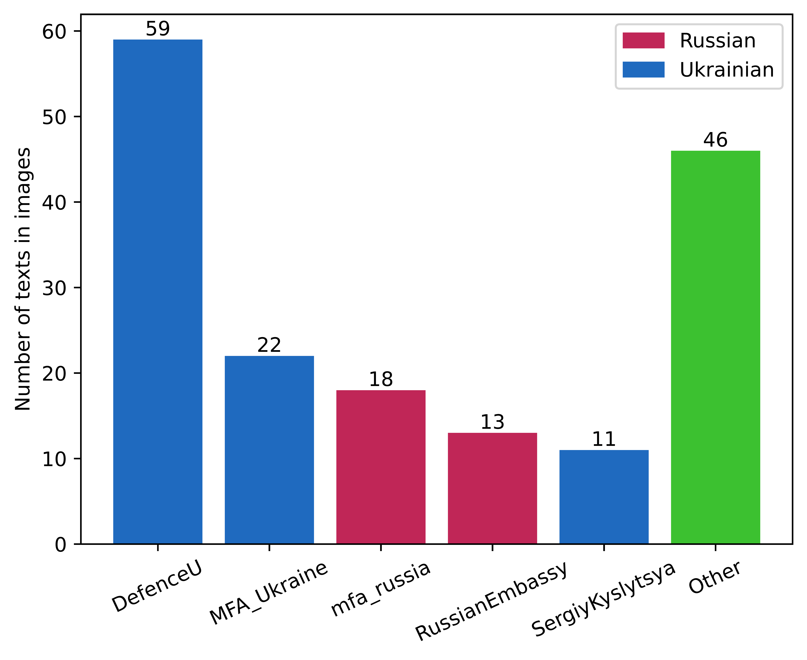

From a computational perspective, this high use of stock portraits for images (about 35% of the whole corpus) and text in images (about 15%) explains why the multimodal models performed worse than a standalone BERT model. Furthermore, while the unimodally pre-trained models such as MMBT used the entire image for feature generation and could thus extract different features even from almost identical images, ViLBERT and VisualBERT used only image regions extracted by Mask-RCNN. It is likely that for stock images, Mask-RCNN would simply extract the human in the image, labeling them as “person”. Having a third of the image set be defined by this one region makes it unusable for a classification task, where the same stock images were likely associated with different labels, differentiated by the text. Similarly, Mask-RCNN was likely able to find the text within the image and label it as such, however, the text in images often reiterated the text associated with the image, and as such, images containing only text would not have any additional benefit over simply using the text. In total, around half of the image corpus consists of pictures that are not beneficial for capturing the differences in propaganda techniques. This suggests that higher care should be taken when evaluating potential data sources for image classification, and that social media may not be the best domain for that. It also raises questions about the performance of similar datasets, such as the Propaganda in Memes dataset (Dimitrov et al., 2021), which used memes for their images, but had much better performances using the same models as this paper. It is possible that much of that performance comes from the text that can be found in the images (as they use the full memes with images intact), rather than the imagery in the meme; this could be a potential area for further research.

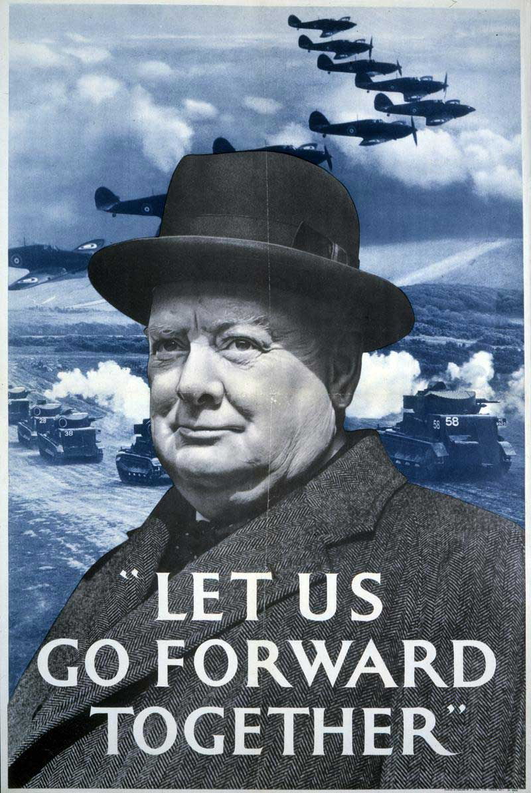

Figure 5: Ministry of Information poster, Second World War. ‘Let us go forward together’, Winston Churchill (INF 13/213 (49)).

#### Russia against the World

When exploring the Russian corpus, a pattern of propaganda against Ukrainian allies can be seen. While Ukraine primarily *smears* and casts *doubt* on Russia, ignoring its allies, such as Belarus, Russia mentions other nations much more. The primary targets of Russian propaganda are the West (mentioned in 151 tweets), the U.S. (97 tweets), and NATO (71 tweets). This follows the rhetoric of Russia that Ukraine was overthrown by nationalists in the 2014 Euromaidan protests, and that it is now a puppet state to the U.S. (Kuzio, 2021), a narrative condensed in a tweet from the Russian MFA: “*FM #Lavrov: We are at war with the collective West led by the United States which is a nuclear power. This war was declared years ago after the coup in Ukraine which was orchestrated by the United States & supported by the EU.*” In other tweets, NATO is mentioned for two reasons: first, the *casus belli* for the invasion was the expansion of NATO towards eastern Europe. Second, since the start of the war, NATO has supplied Ukraine with military and humanitarian aid, and the countries of NATO, largely overlapping with the EU, have put sanctions on the Russian economy. Russia therefore has created a narrative of the West trying to maintain power within the region (and the rest of the world), and Russia trying to create what they call a *multipolarity* in international politics, as in this tweet from the Russian Embassy in London: “*@state_duma Chairman Vyacheslav #Volodin: Washington and Brussels’ plans to isolate #Russia have failed. There is a demand for #multipolarity and a fair world order in the international community.*” Another prong of Russian propaganda is the casting of *doubt* on international organizations that are predominantly influenced by western countries, with series of tweets from Russian accounts dedicated to questioning the impartiality of the OPCW, an organization against chemical weapons, or the Council of Europe, which Russia was expelled from in 2022.

Using these techniques, Russia creates a narrative of being a state focused on creating an impartial, balanced world, where the rich Western countries would not rule over their weaker counterparts in Africa or Asia, and international organizations would not have biases against non-Western states.

#### Ukrainian positive propaganda

The statistical analysis showed that users from Ukraine use significantly more *glittering generalities* and *flag-waving* techniques. While not being statistically significant, some Ukrainian accounts used *plain folks* with a much higher frequency as well. Comparisons on the nationality level of these frequencies can be seen in Figure X. This points to a more “positive” propaganda usage by Ukraine. An example of this is a series of tweets by the Ukrainian Ministry of Defence, showcasing soldiers in a positive light (Figures X, Y), individualizing their stories, framing them as everyday people that had to go to the army to protect their country. Ukrainian president, Volodymyr Zelenskyy, tends to use a lot of positive imagery in his rhetoric as well, such as in this tweet from December 31st, 2022: “*Wish for miracles? [Ukrainians] create them themselves. Want faith, hope? Both have been in the army for a long time. Want light? It's in each of us. Today it's only one wish. It'll come true not by a miracle, but our work. Fight. Mutual aid. Humanity. Happy New Year! Year of our victory”.* This is not new - researchers have noted that during the Euromaidan protests in 2014, the protesters, supporting the current pro-Western government, used positive sentiments a lot more frequently than anti-Maidan users on Twitter (Makhortykh, 2018). When dealing with pro-Russian propaganda in near-Russia territories, NATO officials have described a strategy of using an “army of elves” on social media to construct a “bubble of positive messaging” (Helmus et al., 2018b). Another aspect is the use of animals in propaganda – playing on the emotional attachment most people feel towards dogs (Nagasawa et al., 2009). All of these techniques contribute to a program of “positive” propaganda, where the country and its inhabitants become associated with both explicitly defined generalities such as miracles, hope, light, as well as some implicit positivity resting on the emotional bonds that humans feel towards pets.

This strategy seems to be working – the use of *plain folks* increases the average impression of a tweet (Table X). From a cognitive standpoint, this could be due to these techniques invoking a sense of trustworthiness, which has been shown to work in marketing (Cheung et al., 2008). Showing the personal lives of soldiers, their connections to animals, makes the army appear to be honest, sincere, and similar to the target audience. There is also a certain sense of self-reference, where people digesting these tweets may see themselves in the pictures, and connect as well as remember them better (Sui & Humphreys, 2015). This is especially important in the context of these tweets, because they are aimed at an audience that may not naturally connect with Ukrainian people. As a more subtle use of persuasion, these tweets often include the flag of Ukraine within the image (Figure X), either in a physical form, via military insignia, emojis, or effects on the image. As a variant of *flag-waving*, this technique transfers the emotions the audience feels towards animals or children into feelings towards Ukrainian symbols.

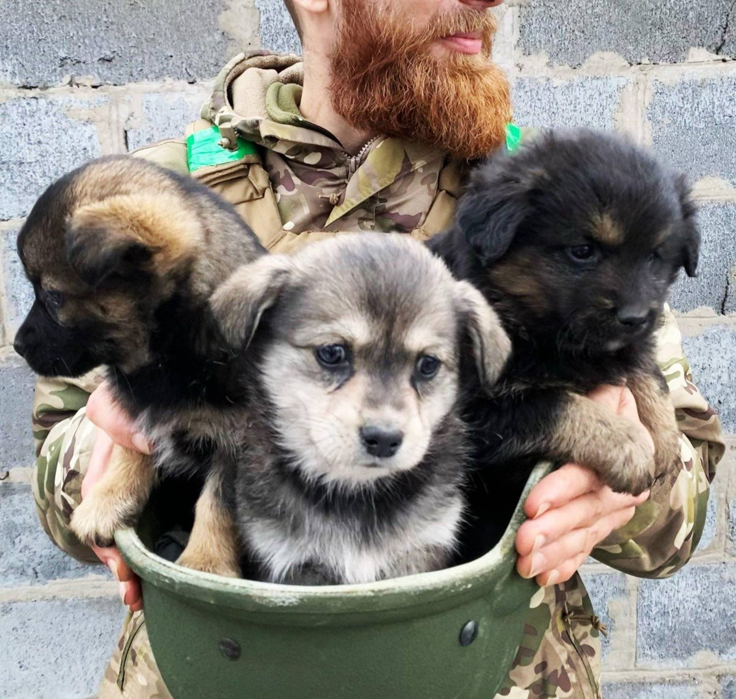

Figure 6: @DefenceU: “Three Dogs in a Helmet (To Say Nothing of the Soldier)”.

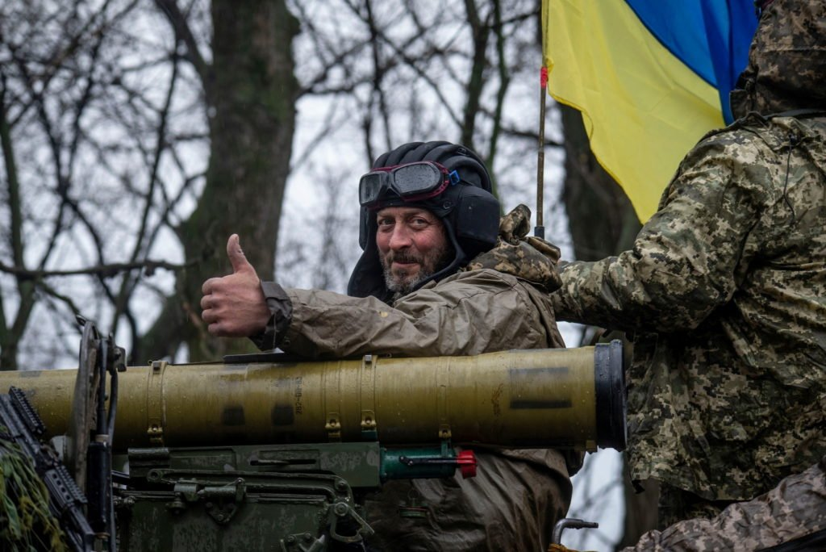

Figure 7: @DefenceU: “Be brave like Ukraine! Be strong like #UAarmy! Be strong! @combined2forces”.

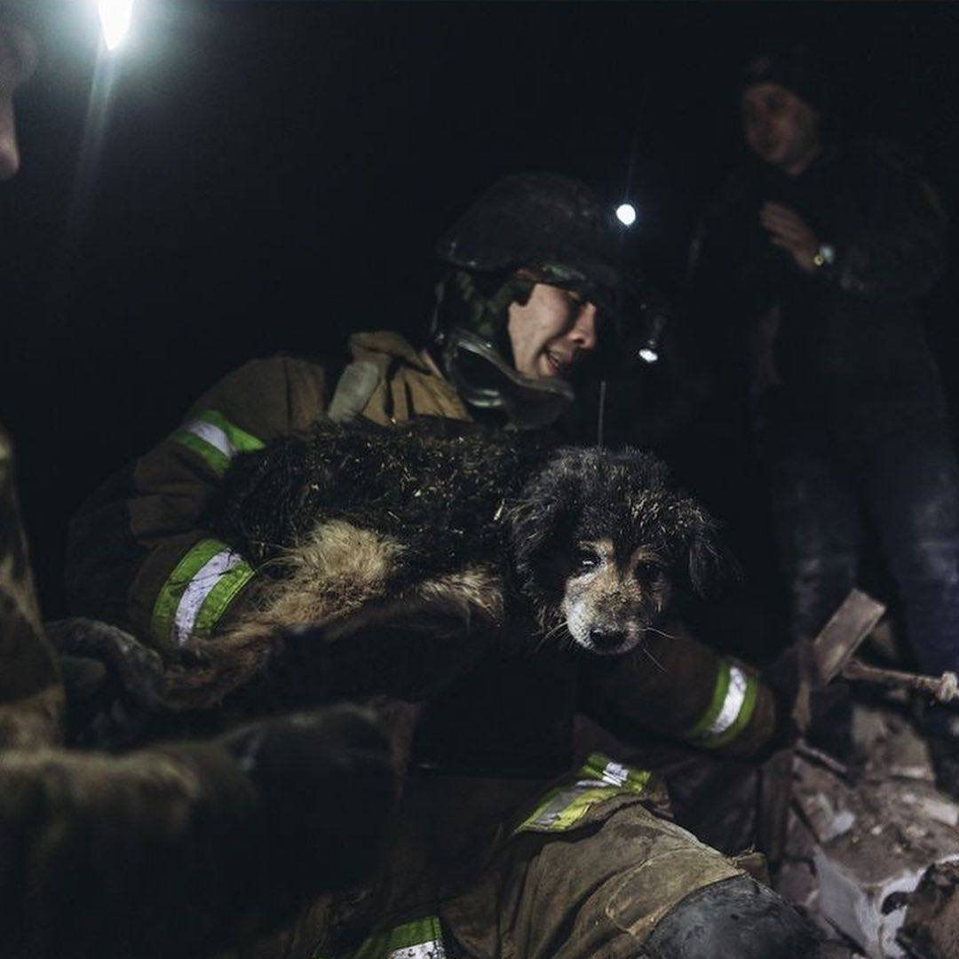

Figure 8: @EmineDzheppar: “The rescuers saved the dog from under the rubble in Chasiv Yar, #Donetsk region. There is no small or big life. We will fight for everyone. #StandWithUkraine”.

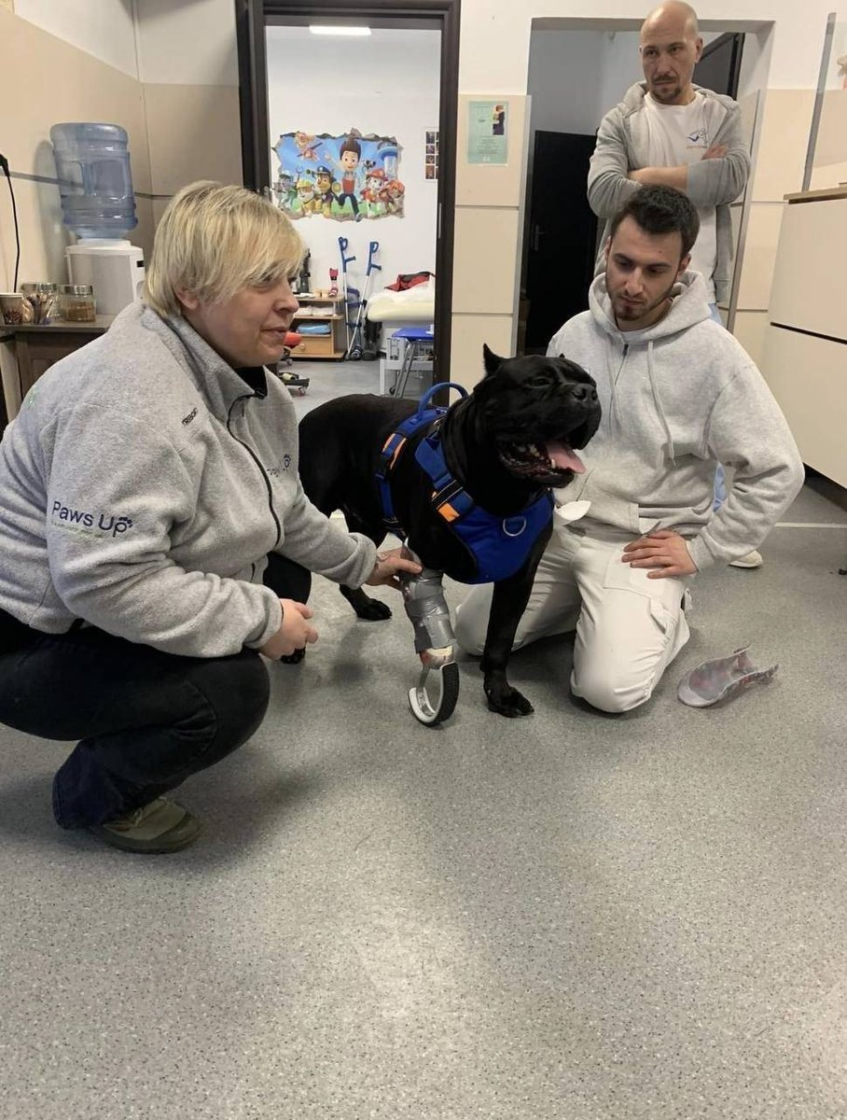

Figure 9: @DefenceU: “Meet Vasya, a heroic recon dog. He was caught in a trap near russian positions, but bit off his paw and returned to his unit. Vasya got a new paw today. Beware, ruscists. Ukrainian dogs of steel are here to prey on you.”



#### Use of social media capabilities

As the data of this corpus comes from social media, it is important to understand how the accounts examined use Twitter capabilities. One of the main factors of spreading a message on Twitter is the inclusion of hashtags, which can be used to create an ecosystem focused on a particular topic. In the corpus, there were two types of hashtags: ones that usually referred to proper nouns, such as *#Russia, #Kiev, #Putin*, and did not seem to have a systematic use; and a second type of hashtag, that acted as a slogan as well. The latter set included hashtags such as #RussiaIsATerroristState, #StandWithUkraine, #LifeWillPrevail; these types of slogans were used almost entirely by Ukrainian accounts (Figure X). This points to the Ukrainian accounts putting more effort in using the opportunities social media provides. The fact that the hashtags double as short slogans, which have *glittering generalities, flag-waving,* and *name-calling* in them, makes them a good example of propaganda spread in the age of social media. In general, as can be seen from the data (Figures X, Y), Ukrainians used more hashtags and slogans (which often doubled), but the words in their tweets were longer and harder to comprehend. This points to a strategy of using a combination of long, verbose sentences combined with short, striking slogans to provide their messages both fast emotional appeal as well as denser content.

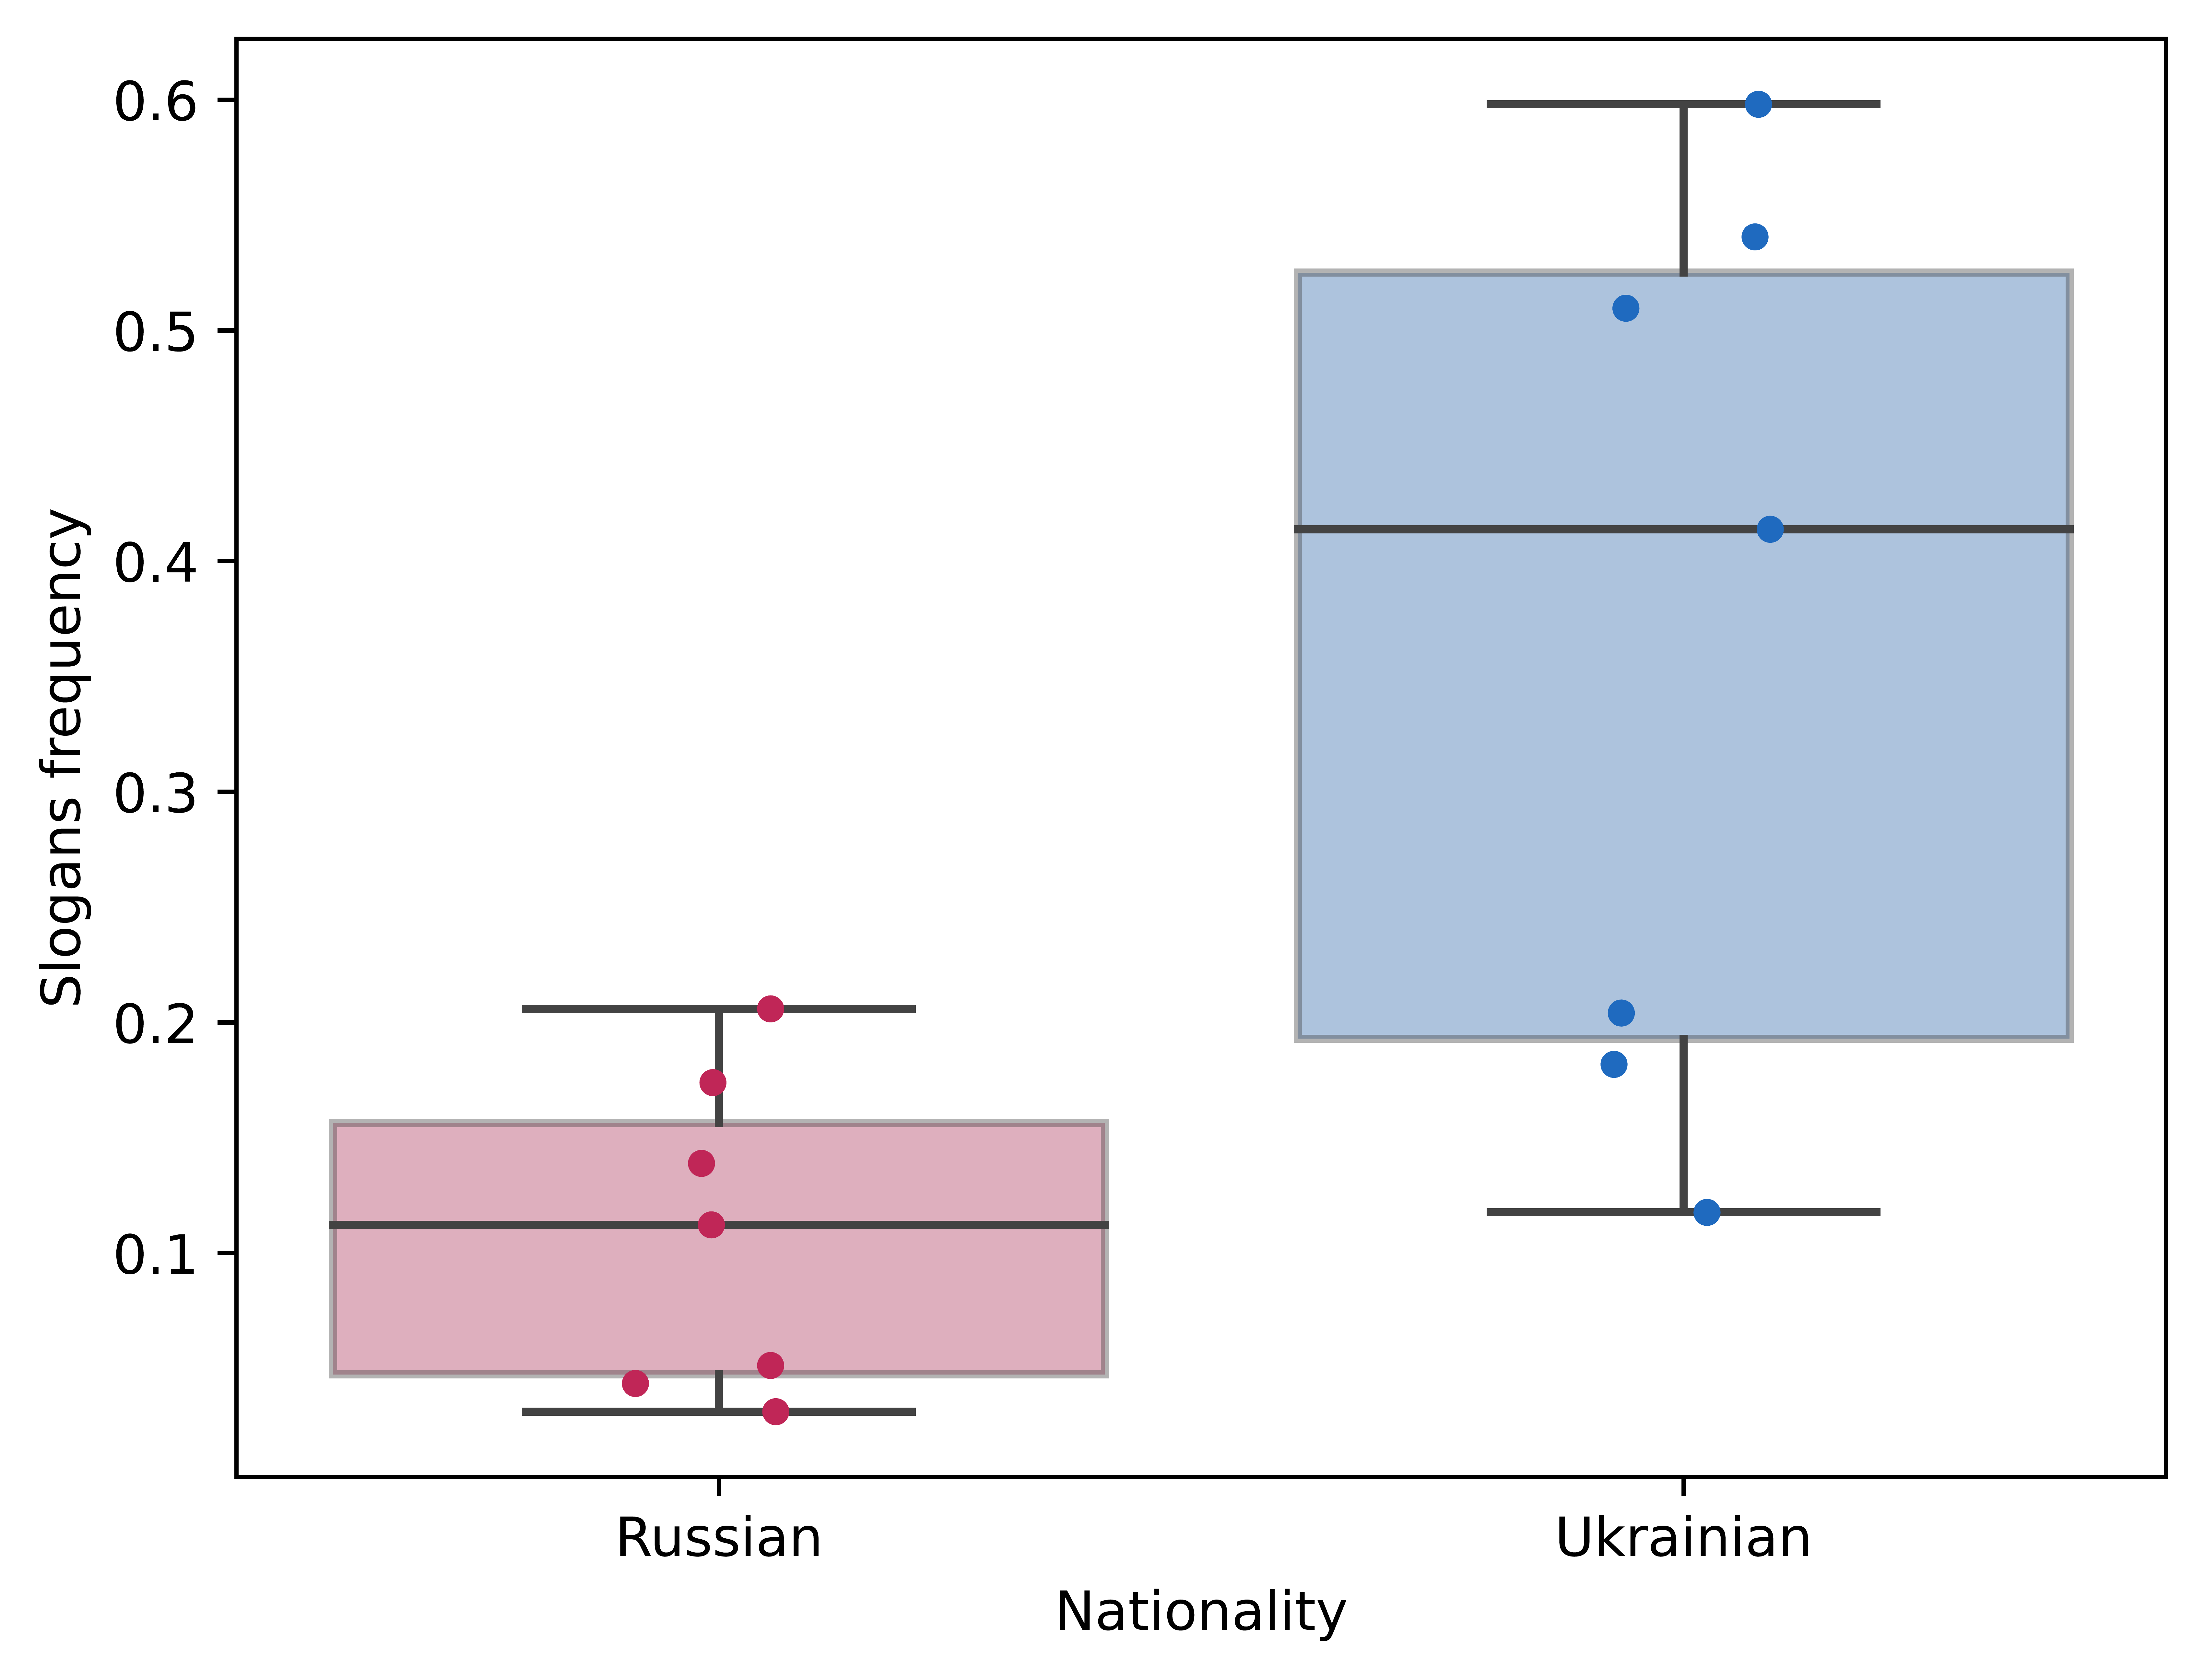

On the other hand, according to the statistical models used, the use of *repetitions* decreases the average impressions count of a tweet (Table X). This suggests that Twitter users do not engage with posts which are either a repetition of a format, or are self-repeating (Figure X), though the former version appears much more commonly. The most common is the Ukrainian Ministry’s of Defence updates on the number of Russian casualties (Figure X). A decrease in impressions is supported by marketing literature – visual repetition leads to a decrease in attention (Pieters et al., 1996). Research into relevant social media content found that users enjoyed diversity, but perceived content as being most relevant when it had either a high level of heterogeneity or a high level of homogeneity (De Choudhury et al., 2011). This provides an explanation for why the daily updates perform badly – they are repetitive themselves, but combined with the rest of the corpus that the Ministry of Defence posts, make the entire feed neither very heterogenous nor homogenous. However, it is likely that the MOD account is now required to post these updates, as an absence may indicate that Russian forces suffered no losses.

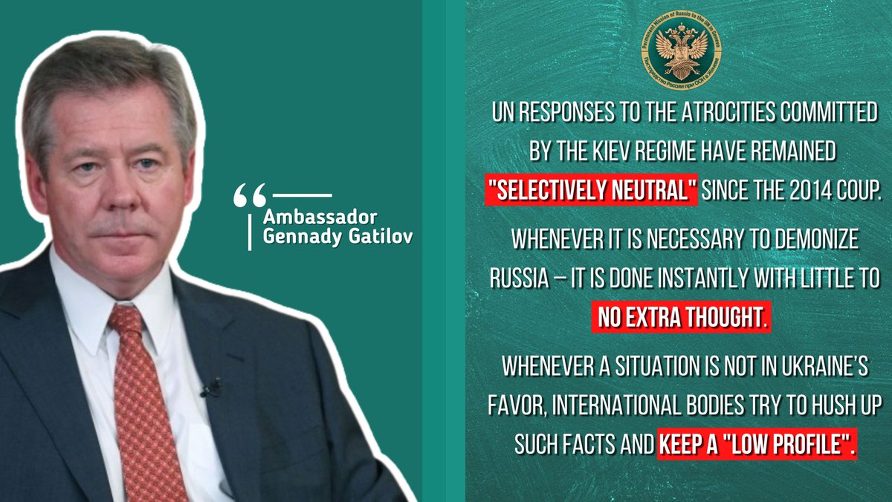

Figure 10: @mission_russian: “Ambassador @GGatilov: UN responses to the atrocities committed by the Kiev regime have remained “selectively neutral” since the 2014 coup. Need to demonize Russia - no problem. Something casts a shadow on Ukraine - let’s hush it up and keep a “low profile”. “

#### Images of destruction

As mentioned before, around half of the images are made up of portraits and text. These types of pictures do not provide any interesting aspects to consider. In the rest of the data, images of missile attacks and destroyed buildings are used relatively frequently (Figures X, Y), and constitute most of what is labeled as *appeal to fear* in the dataset (Figure X). Most of the time, they only feature property, however, there are some instances of shown fatalities in the corpus as well (Figure X). Two main types of *fear* images used by Ukrainian accounts can be observed. The majority of them show the impact of Russian attacks on Ukrainian land, and often include text captions detailing the number of deaths (frequently differentiating between adults and children). A small portion of them show Russian casualties instead, appealing to the fear of the attackers. Russian users do not post many instances of destruction; their *appeals to fear* are in large part related to the potential disturbance of nuclear power plants (Figure X) and the use of nuclear weapons, as in this tweet by the Russian Embassy in London: “*FM #Lavrov: Western policy of total containment of #Russia is extremely dangerous and can escalate into a direct armed confrontation between #nuclear powers. We have been warning them about this, and we continue to repeat that a #nuclearwar cannot be won and must never be fought”*.

Destruction is used as a shortcut for emotions, most notably fear and anger. Research on terror management has shown that images of destroyed buildings increase support for war and military aggression against those deemed responsible (Vail et al., 2012). This type of propaganda taps into the fact that casualties are almost always civilians, and allows the user to easily vilify the aggressor. Fear can be used for mobilization as well; this has been noted to work both on the German people in World War II, as well as on the American population during the cold war, where totalitarian government actions and citizen’s support for them were motivated by the fear of communism (Romarheim, 2005). From a cognitive perspective, persuasion via a high level of fear has been shown to make the consumer think less about the specific message content, and more about ideas peripheral to it, something that has been described as heuristic message processing (Hale et al., 1995). This should be beneficial for propaganda, as the single image may be transformed into a representation of the war, or the enemy’s aggression itself.

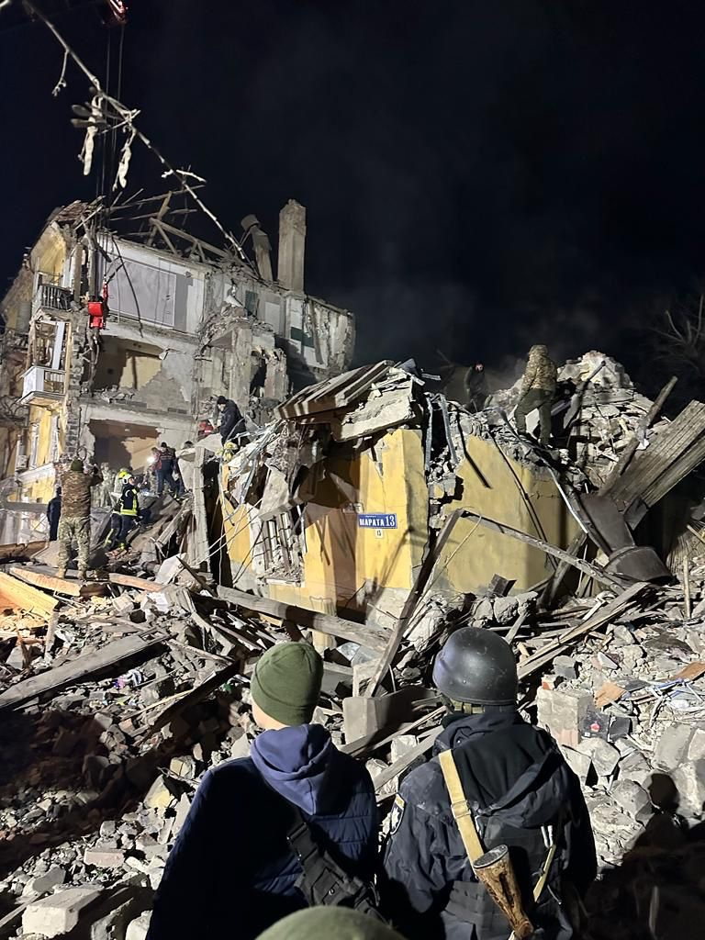

Figure 11: @ZelenskyyUA: “Kramatorsk. Russian terrorists have hit the city with a ballistic missile leading to civilian casualties. Some people are still under the rubble. No goal other than terror. The only way to stop Russian terrorism is to defeat it. By tanks. Fighter jets. Long-range missiles.”

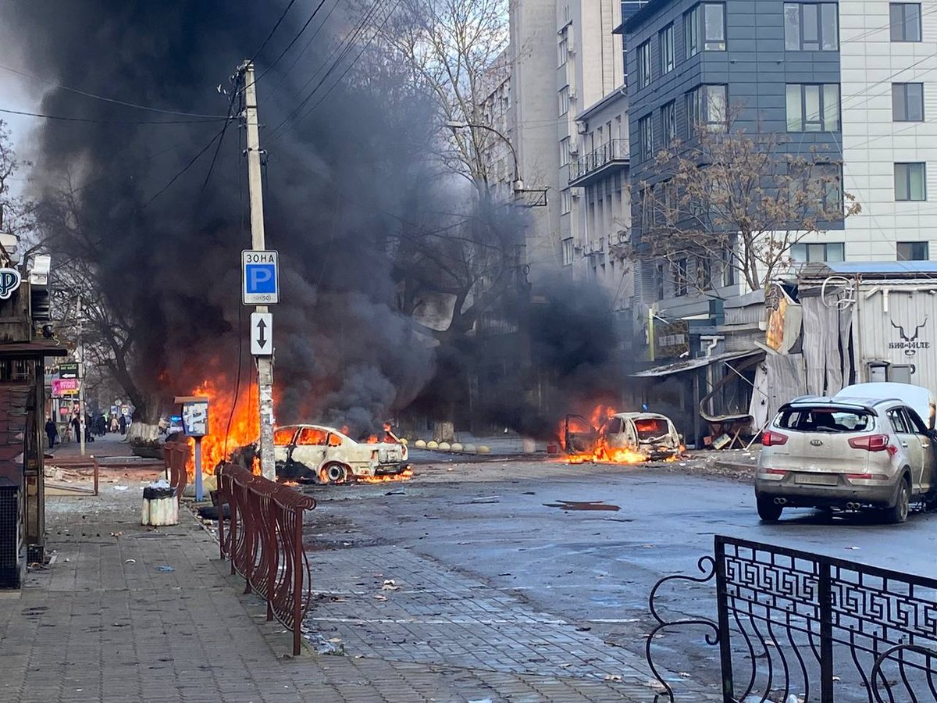

Figure 12: @ZelenskyyUA: “This is not sensitive content – it's the real life of [Ukraine]. Kherson. On the eve of Christmas, in the central part of the city. It's terror, it's killing for the sake of intimidation and pleasure. The world must see what absolute evil we are fighting against. #russiaisateroriststate”.

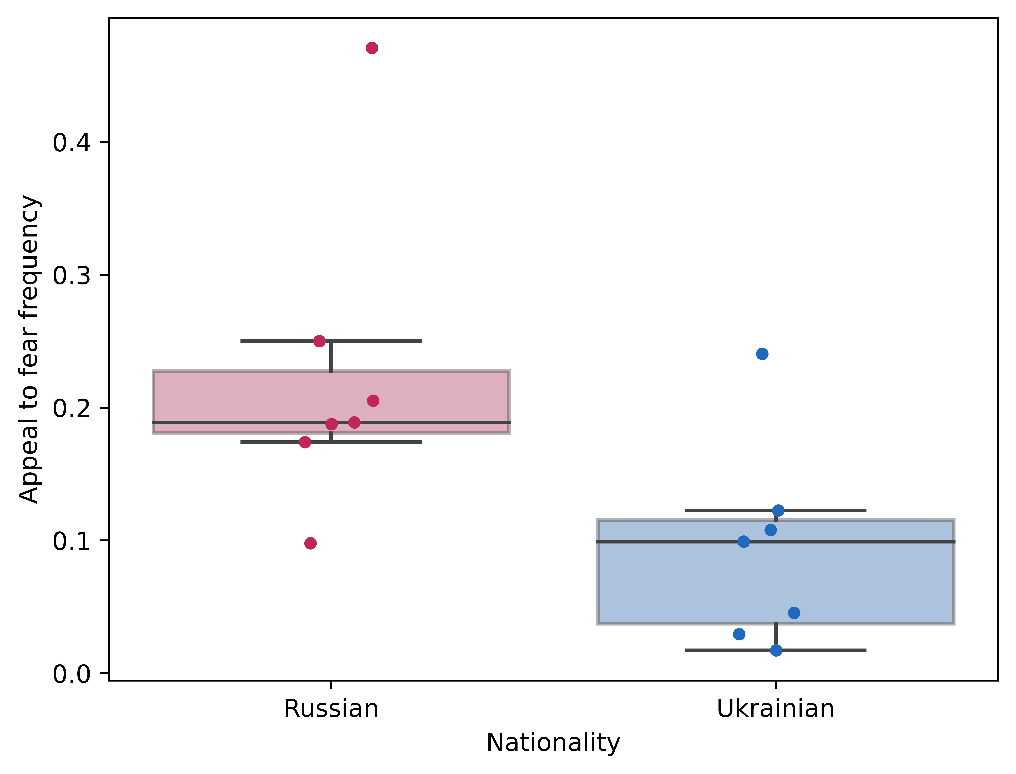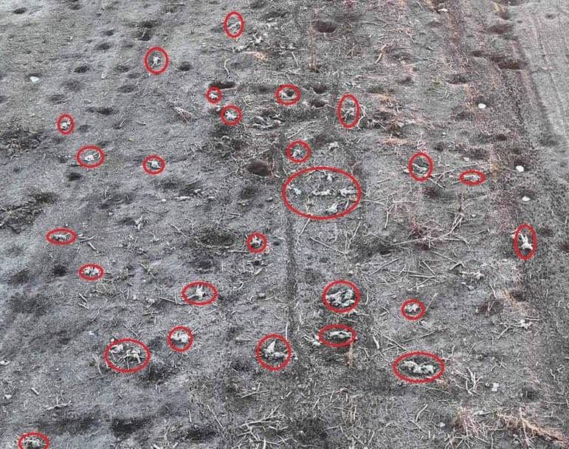

Figure 13: @DefenceU: “Never before has the russian diplomatic corps suffered such losses.”

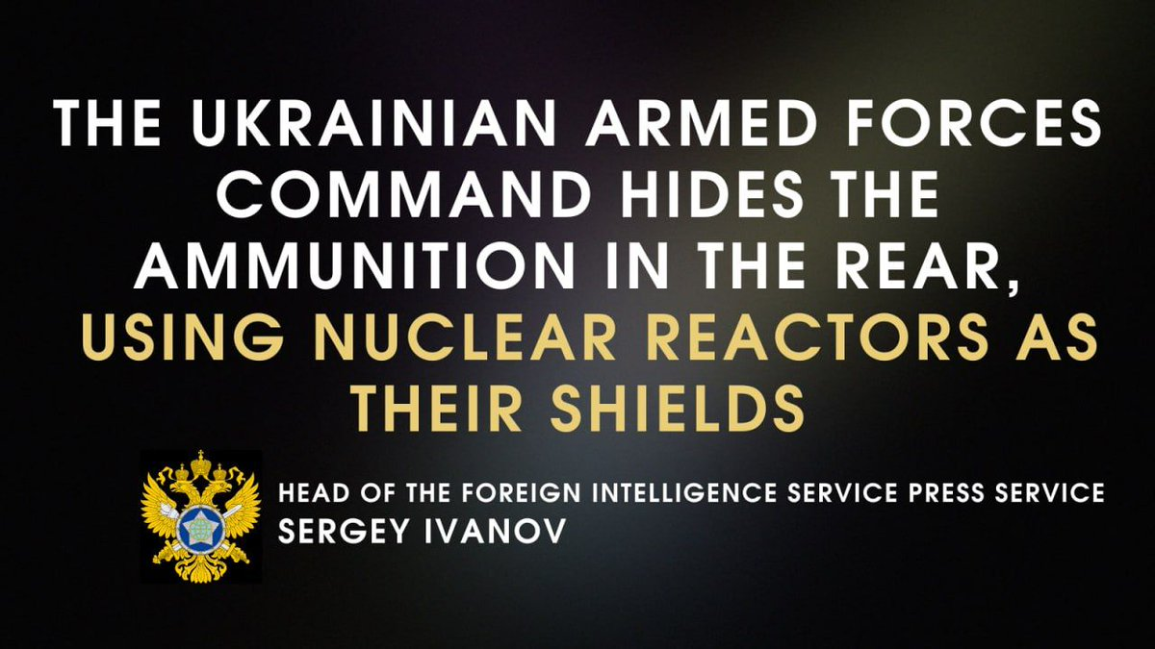

Figure 14: @RussianEmbassy: “ [Russian] Foreign Intelligence Service: [Ukrainian] armed forces store Western & ammunition at nuclear power stations, using #nuclear reactors as shields. Like intl terrorists, #Kievregime uses tens or even hundreds of thousands of civilians in its own and neighbouring countries as hostages.”

#### Nazis, terrorists, the regime, and capitalization

An interesting part of the war on social media is the type of language used for framing the conflict by both sides. The use of *reductio ad hitlerum* has been a core aspect of Russian political communication about the war. Part of the justification of the invasion was the “de-nazification” of Ukraine (Longobardo, 2022), and Ukrainians are regularly compared both to historic nazis as well as neo-nazis (Figure X). Russian authorities use this rhetoric for two main reasons: first, it justifies the use of military force in Ukraine. A narrative of Ukraine oppressing Russian-speaking citizens has been formed by Russian propaganda (Kuzio, 2021), with Russia acting as a “mother”, helping these citizens by clearing the country of nazis.

Second, Russian media created a parallel between the World War II victory over Nazis and the modern day war with Ukraine (Rossoliński-Liebe & Willems, 2022). This is linked by topics such as Stepan Bandera, a controversial WWII era Ukrainian labeled as a fascist war criminal by Russians and as a nationalist fighter for independence by Ukrainians (Shevtsova, 2022). The soviet win in World War II has been recaptured by Russian ideological leaders as a basis for the state’s national identity, because the cult-like narrative had been effectively instituted in the late-Soviet period and enjoyed a high level of acceptance from the post-soviet population (Malinova, 2017). The historic memory of the second World War has been used to frame the current Russo-Ukrainian war as a repeat of the Soviet-Nazi fight in the 20th century.

A narrative related to this is one that places Ukraine as part of Russia. This is in part supported by Russia claiming direct descent of the Soviet Union. An example of this rhetoric can be seen in a tweet from the Russian mission to the UN (Figure X). It uses a soviet-era poster with the words “Our Friendship is Our Strength” in Cyrillic, and a diverse set of people – signifying the numerous different republics in the Soviet Union – appearing to enjoy each other’s presence. The text of the tweet explains how Ukraine was not a sovereign state during it’s soviet occupation. The text, combined with the image, implies that Ukraine would be stronger if it were once again part of Russia. This framing of Ukraine as part of Russia was amplified by Vladimir Putin who, three days before the invasion of Ukraine, claimed that Ukraine “has never had authentic statehood”, that it was created by Lenin under the Soviet Union, and that it is “an integral part” of Russian history and culture (Baker, 2022).

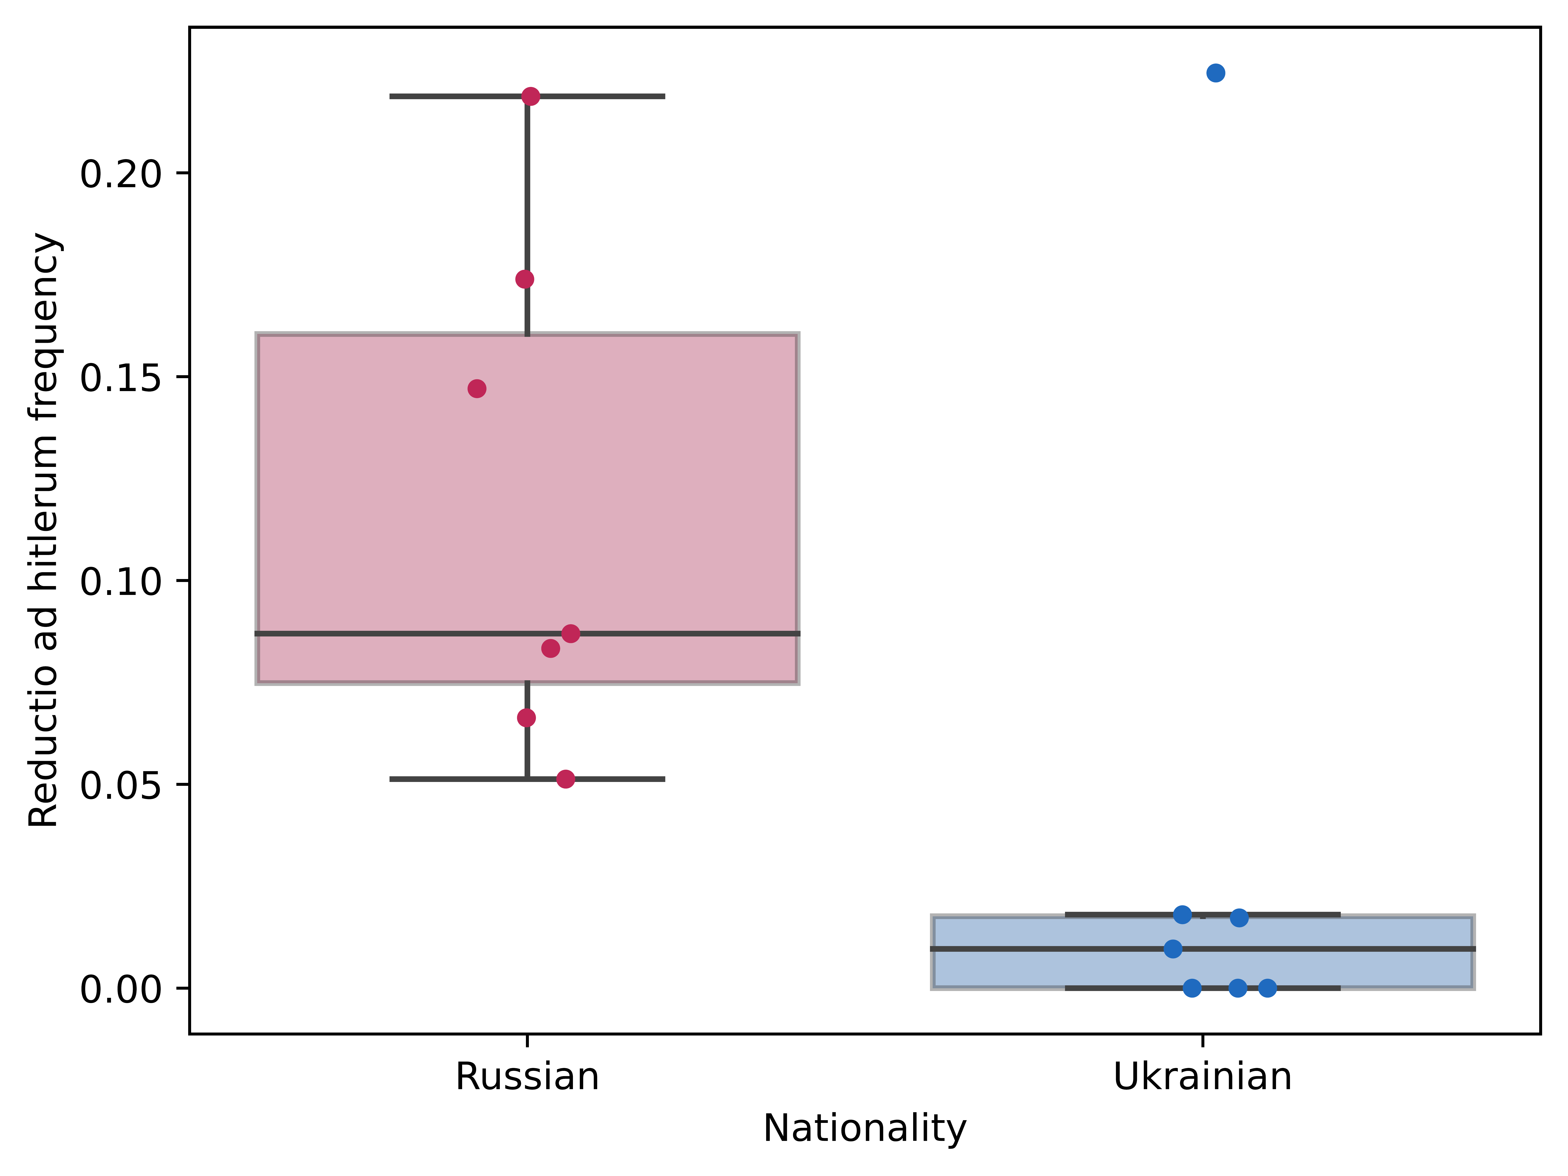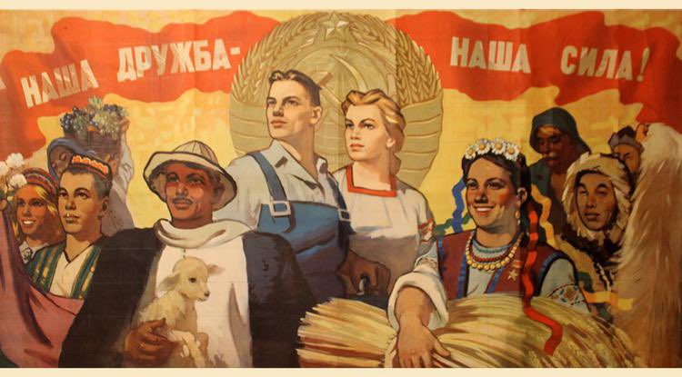

Figure 15: @mission_russian: “Undeniable fact: Ukraine wasn’t a sovereign country in 1946-91. In 1945 Stalin insisted that all Soviet republics must be represented at the UN separately (and the US opposed this initiative). Thus, only Ukrainian and Belorussian SSRs were allowed separate UN seats.”

On the side of Ukraine, name calling has been quite frequent as well (Figure X). Unlike the use of “nazi” by Russian users, Ukrainian accounts used more generic names, such as *terrorists* (used in 74 tweets), *occupiers* (30 tweets), *invader*s (18 tweets). All of these names evoke a sense of illegality in the actions of the Russian army. This may be duo to the fact that the tweets are aimed at an international audience. The main tool of support the West has used during the war is sanctioning, with 70% of Russian banking assets frozen (Impact of Sanctions on the Russian Economy, 2023). The constant association of Russians with illegal measures could be used to amplify the view of the war through legal ramifications. These words could also be used to signify Ukraine as the victim of the war, which is a well-documented way of garnering sympathy and appealing to senses of responsibility and morality (MacDonald, 2003).

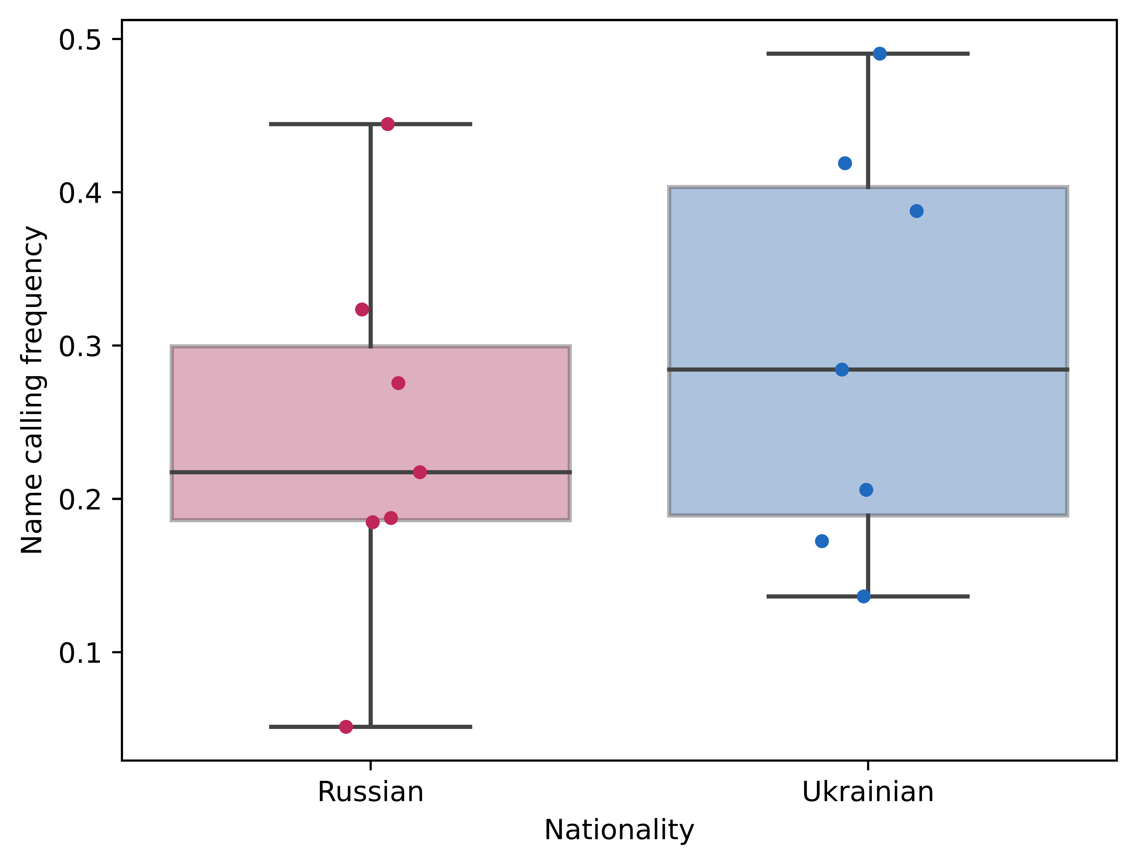

There is an extreme outlier visible in the Ukrainian data on *reductio ad hitlerum* frequency (Figure X). This outlier is Sergiy Kyslytsya, the representative of Ukraine to the UN. Interestingly, while Russian uses of this technique center around calling Ukrainians nazis quite frequently, this user is the only Ukrainian who makes frequent comparisons of Russia and Nazi Germany. There is one datapoint from him disparaging the Russian-claimed Soviet Union as well, seen in this tweet: “*I was about to recognize the presence of nebenzia’s number 2 but he hastily retreated from the UNSC meeting on the consequences of russian aggression. This acolyte of two Josephs, Stalin and Goebbels, who never lets the truth to interrupt the endless flow of his prolixity of lies*”.

There are two more interesting word uses to consider, and both of them are related to how the users refer to their enemies in war. Russian accounts frequently used the term *Kiev regime* (used in 57 tweets). While the word *regime* originally meant any type of government, and is still defined as such by Webster dictionary (Merriam-Webster, n.d.), modern uses have a negative connotation, and Oxford Advanced Learner’s Dictionary defines regime as “a method or system of government, especially one that has not been elected in a fair way” (Oxford Advanced Learner’s Dictionary, n.d.). In this way, Russian users want to associate the government of Ukraine with totalitarianism and illegitimacy.

A subtler denunciation is the non-capitalization of the word *Russia* in Ukrainian messages. The capitalized version is used in 112 tweets, while the lowercase *russia* appears in 138 messages. While some of these can be attributed to translation differences – derivative adjectives are not capitalized in the Ukrainian language – and the standards of language in social media, the large number of misuses indicate a systematic usage. In an opinion piece two months into the war, Ukrainian political analyst Roman Rukomeda said that he never capitalizes the words *Russia* or *Putin*, because they are, respectively, a “terrorist state” and a “bloody criminal dictator”, and do not deserve to be capitalized (Rukomeda, 2022). This sentiment seems to be shared by the Ukrainian users in this corpus. Decapitalization has been called a *sly slur* (Allen, 1988)*,* and has been analyzed as a technique of diminishing the social status of a group, and has been used in World War II by Polish writers, with their use of *niemec* (“German”) (Roback, 1944).

Overall, there are some very specific, largely systematic uses of language found within the propaganda in this corpus. On the surface, they are mostly insults and defamation of the enemy. However, some instances feature a deeper meaning, passively delegitimizing the opposing government, amplifying a narrative of victimhood, and creating a rhetoric which dehumanizes the enemy.

# Conclusion, Limits, Future Work

This thesis evaluated how Russian and Ukrainian government officials use social media in their spread of propaganda about the Russo-Ukrainian war. To do this, a corpus of multimodal – text and image – data was collected from Twitter and analysed. An approach of both machine learning and statistical analysis to gain insight into the data was used; the results of these analyses were then examined in the form of case studies. The following main results were found: i) Social media data, particularly images, are not beneficial in the training of models for propaganda technique classification, as they do not successfully convey the intrinsic attributes of the techniques classified; ii) There are significant differences in the types of propaganda that Russian and Ukrainian accounts use, with Ukrainians focusing on what in this paper is defined as “positive” propaganda more, while Russians tend to smear, focus on Ukraine’s allies, and appeal to authority more; iii) There are some slight differences in the way that organizations and individuals propagate their ideas, with individuals using less words and more slogans; iv) Repeating messages get less views than average, while appealing to common folk gets more impressions.

There are limits to this study that should be kept in mind when evaluating the results. The biggest limit is the dataset. The data was collected from a limited number of accounts, and labeled by a single person. Around a third of the evaluated data could not be used due to not being relevant to the war. It should be noted that while the number of accounts is small, this is largely due to the ecosystem of Russian and Ukrainian accounts on Twitter at the time of data collection. Many Russian accounts had been suspended, while Ukrainian accounts did not have official status, and only accounts posting in English were used. From the author’s point of view, the accounts used were all of the accounts that *could* be used without doing an account search that was out of scope or using unofficial accounts. The second limitation is the poor results when examining which propaganda techniques increased the impression counts. There are two potential reasons: first, the data may be too difficult to label, which is realistic – multilabel tasks with 20 labels are rare and difficult, the features used (propaganda techniques) are largely semantic in nature, which is not the strong suit of classifiers, and the data is labeled by a single person, which might incur inconsistencies. The second reason could be the fact that the models used were too simple. They are both essentially linear regression models, and a dataset of this difficulty could require some stronger models for good performance.

There are a number of avenues for future work. Other than overcoming the limitations set out above, it would be interesting to apply this methodology to a known high quality dataset, which had more datapoints. I believe it could provide more insight into what propaganda spreads well on social media, and allow researchers to examine why it works better. It would also be interesting to evaluate a dataset consisting of ordinary people. While the dataset examined in this paper has emotional statements and quite aggressive rhetoric, it is still based on officials and organizations which generally use a formal tone and communicate in a professional manner. A different landscape of discussion could see some other propaganda techniques emerge as the most used and useful. Another aspect that is not explored here is time. In the age of social media, updates on war come in almost in real time, and the narratives can change in a few days. It would be interesting to examine if the use of specific propaganda techniques changes over time, and how much impressions, techniques, and time interplay with each other.

# References

Abd Kadir, S., & Abu Hasan, A. S. (2014). A content analysis of propaganda in Harakah newspaper. Journal of Media and Information Warfare (JMIW), 5, 73–116.  
, Aiello, G., & Parry, K. (2019). Visual communication: Understanding images in media culture. Sage.  
, Allen, I. L. (1988). Sly slurs: mispronunciation and decapitalization of group names. Names, 36(3–4), 217–224.  
, Anderson, J. (1983). Lix and Rix: Variations on a Little-known Readability Index. Journal of Reading, 26(6), 490–496. https://www.jstor.org/stable/40031755  
, Arevalo, J., Solorio, T., Montes-y-Gómez, M., & González, F. A. (2017). Gated multimodal units for information fusion. ArXiv Preprint ArXiv:1702.01992.  
, Atrey, P. K., Hossain, M. A., El Saddik, A., & Kankanhalli, M. S. (2010). Multimodal fusion for multimedia analysis: a survey. Multimedia Systems, 16(6), 345–379. https://doi.org/10.1007/s00530-010-0182-0  
, Baker, S. (2022, February 22). Putin denies planning to revive the Russian empire after declaring that Ukraine is not a real country and sending troops there. Business Insider. https://www.businessinsider.com/putin-denies-reviving-russian-empire-says-ukraine-not-real-country-2022-2  
, Bondarenko, I. (2020). Tools of Explicit Propaganda: Cognitive Underpinnings. Open Journal of Modern Linguistics, 10(01), 23–48. https://doi.org/10.4236/ojml.2020.101003  
, Carey, A. (1997). Taking the risk out of democracy: Corporate propaganda versus freedom and liberty. University of Illinois Press.  
, Chen, X., Fang, H., Lin, T.-Y., Vedantam, R., Gupta, S., Dollar, P., & Zitnick, C. L. (2015). Microsoft COCO Captions: Data Collection and Evaluation Server (arXiv:1504.00325). arXiv. http://arxiv.org/abs/1504.00325  
, Cheung, C. M. K., Lee, M. K. O., & Rabjohn, N. (2008). The impact of electronic word‐of‐mouth: The adoption of online opinions in online customer communities. Internet Research, 18(3), 229–247. https://doi.org/10.1108/10662240810883290  
, Cikara, M., Bruneau, E. G., & Saxe, R. R. (2011). Us and Them: Intergroup Failures of Empathy. Current Directions in Psychological Science, 20(3), 149–153. https://doi.org/10.1177/0963721411408713  
, Clayton, J. (2022, April 5). Twitter moves to limit Russian government accounts. BBC News. https://www.bbc.com/news/technology-60992373  
, Confucius. (n.d.). The Analects. Retrieved April 18, 2023, from http://archive.org/details/theanalectsconfucius  
, De Choudhury, M., Counts, S., & Czerwinski, M. (2011). Identifying relevant social media content: leveraging information diversity and user cognition. Proceedings of the 22nd ACM Conference on Hypertext and Hypermedia, 161–170. https://doi.org/10.1145/1995966.1995990  
, Deng, J., Dong, W., Socher, R., Li, L.-J., Li, K., & Fei-Fei, L. (2009). ImageNet: A large-scale hierarchical image database. 2009 IEEE Conference on Computer Vision and Pattern Recognition, 248–255. https://doi.org/10.1109/CVPR.2009.5206848  
, Derczynski, L. (2016). Complementarity, F-score, and NLP Evaluation. Proceedings of the Tenth International Conference on Language Resources and Evaluation (LREC’16), 261–266. https://aclanthology.org/L16-1040  
, Devlin, J., Chang, M.-W., Lee, K., & Toutanova, K. (2019a). BERT: Pre-training of Deep Bidirectional Transformers for Language Understanding (arXiv:1810.04805). arXiv. https://doi.org/10.48550/arXiv.1810.04805  
, Devlin, J., Chang, M.-W., Lee, K., & Toutanova, K. (2019b). BERT: Pre-training of Deep Bidirectional Transformers for Language Understanding (arXiv:1810.04805). arXiv. http://arxiv.org/abs/1810.04805  
, Devlin, J., Chang, M.-W., Lee, K., & Toutanova, K. (2019c). BERT: Pre-training of Deep Bidirectional Transformers for Language Understanding (arXiv:1810.04805). arXiv. https://doi.org/10.48550/arXiv.1810.04805  
, Dimitrov, D., Ali, B. B., Shaar, S., Alam, F., Silvestri, F., Firooz, H., Nakov, P., & Martino, G. D. S. (2021). Detecting Propaganda Techniques in Memes (arXiv:2109.08013). arXiv. http://arxiv.org/abs/2109.08013  
, Ding, H., Feng, P.-M., Chen, W., & Lin, H. (2014). Identification of bacteriophage virion proteins by the ANOVA feature selection and analysis. Molecular BioSystems, 10(8), 2229–2235. https://doi.org/10.1039/C4MB00316K  
, Dorney, H. (n.d.). The dos and don’ts of Twitter images. Retrieved May 27, 2023, from https://business.twitter.com/en/blog/do-dont-twitter-images.html  
, Dowe, T. (1997). News You Can Abuse. Wired. https://www.wired.com/1997/01/netizen-6/  
, El-Khalili, S. (2013). Social media as a government propaganda tool in post-revolutionary Egypt. First Monday.  
, Ellul, J. (2021). Propaganda: The formation of men’s attitudes. Vintage.  
, Forgas, J. P., & Koch, A. S. (2013). Mood effects on cognition. In Handbook of cognition and emotion (pp. 231–251). The Guilford Press.  
, Gerber, T. P., & Zavisca, J. (2016). Does Russian Propaganda Work? The Washington Quarterly, 39(2), 79–98. https://doi.org/10.1080/0163660X.2016.1204398  
, Ghannam, J. (2011). Social Media in the Arab World: Leading up to the Uprisings of 2011. Center for International Media Assistance, 3(1), 1–44.  
, Gundapu, S., & Mamidi, R. (2022). Detection of Propaganda Techniques in Visuo-Lingual Metaphor in Memes (arXiv:2205.02937). arXiv. http://arxiv.org/abs/2205.02937  
, Gunning, R. (1969). The Fog Index After Twenty Years. Journal of Business Communication, 6(2), 3–13. https://doi.org/10.1177/002194366900600202  
, Hale, J. L., Lemieux, R., & Mongeau, P. A. (1995). Cognitive processing of fear-arousing message content. Communication Research, 22(4), 459–474.  
, Hansen, L., Olsen, L. R., & Enevoldsen, K. (2023). TextDescriptives: A Python package for calculating a large variety of metrics from text (arXiv:2301.02057). arXiv. https://doi.org/10.48550/arXiv.2301.02057  
, Hastie, T., & Tibshirani, R. (1987). Generalized Additive Models: Some Applications. Journal of the American Statistical Association, 82(398), 371–386. https://doi.org/10.1080/01621459.1987.10478440  
, He, K., Gkioxari, G., Dollár, P., & Girshick, R. (2018). Mask R-CNN (arXiv:1703.06870). arXiv. https://doi.org/10.48550/arXiv.1703.06870  
, He, K., Zhang, X., Ren, S., & Sun, J. (2016). Deep Residual Learning for Image Recognition. 2016 IEEE Conference on Computer Vision and Pattern Recognition (CVPR), 770–778. https://doi.org/10.1109/CVPR.2016.90  
, Helmus, T. C., Bodine-Baron, E., Radin, A., Magnuson, M., Mendelsohn, J., Marcellino, W., Bega, A., & Winkelman, Z. (2018a). Russian social media influence: Understanding Russian propaganda in Eastern Europe. Rand Corporation.  
, Helmus, T. C., Bodine-Baron, E., Radin, A., Magnuson, M., Mendelsohn, J., Marcellino, W., Bega, A., & Winkelman, Z. (2018b). Russian Social Media Influence: Understanding Russian Propaganda in Eastern Europe. Rand Corporation.  
, Honnibal, M., Montani, I., Van Landeghem, S., & Boyd, A. (2020). spaCy: Industrial-strength Natural Language Processing in Python. https://doi.org/10.5281/zenodo.1212303  
, Huang, J., & Ling, C. X. (2005). Using AUC and accuracy in evaluating learning algorithms. IEEE Transactions on Knowledge and Data Engineering, 17(3), 299–310. https://doi.org/10.1109/TKDE.2005.50  
, Impact of sanctions on the Russian economy. (2023, May 4). https://www.consilium.europa.eu/en/infographics/impact-sanctions-russian-economy/  
, Jowett, G. S., & O’Donnell, V. (2011). Propaganda & Persuasion. SAGE Publications.  
, Kiela, D., Bhooshan, S., Firooz, H., Perez, E., & Testuggine, D. (2020). Supervised Multimodal Bitransformers for Classifying Images and Text (arXiv:1909.02950). arXiv. http://arxiv.org/abs/1909.02950  
, Kiela, D., Firooz, H., Mohan, A., Goswami, V., Singh, A., Ringshia, P., & Testuggine, D. (2020). The Hateful Memes Challenge: Detecting Hate Speech in Multimodal Memes. Advances in Neural Information Processing Systems, 33, 2611–2624. https://proceedings.neurips.cc/paper/2020/hash/1b84c4cee2b8b3d823b30e2d604b1878-Abstract.html  
, Kłosowski, P. (2018). Deep Learning for Natural Language Processing and Language Modelling. 2018 Signal Processing: Algorithms, Architectures, Arrangements, and Applications (SPA), 223–228. https://doi.org/10.23919/SPA.2018.8563389  
, Krishna, R., Zhu, Y., Groth, O., Johnson, J., Hata, K., Kravitz, J., Chen, S., Kalantidis, Y., Li, L.-J., Shamma, D. A., Bernstein, M. S., & Li, F.-F. (2016). Visual Genome: Connecting Language and Vision Using Crowdsourced Dense Image Annotations (arXiv:1602.07332). arXiv. https://doi.org/10.48550/arXiv.1602.07332  
, Kuzio, T. (2021). Russian Nationalism and the Russian-Ukrainian War: Autocracy-Orthodoxy-Nationality (1st ed.). Routledge. https://doi.org/10.4324/9781003191438  
, Laskin, A. V. (2019). Defining propaganda: A psychoanalytic perspective. Communication and the Public, 4(4), 305–314.  
, Lee, A., & Lee, E. B. (1939). The fine art of propaganda.  
, Li, L. H., Yatskar, M., Yin, D., Hsieh, C.-J., & Chang, K.-W. (2019). VisualBERT: A Simple and Performant Baseline for Vision and Language (arXiv:1908.03557). arXiv. http://arxiv.org/abs/1908.03557  
, Liadze, I., Macchiarelli, C., Mortimer-Lee, P., & Sanchez Juanino, P. (2022). Economic costs of the Russia-Ukraine war. The World Economy, 46(4), 874–886. https://doi.org/10.1111/twec.13336  
, Liu, Y., Ott, M., Goyal, N., Du, J., Joshi, M., Chen, D., Levy, O., Lewis, M., Zettlemoyer, L., & Stoyanov, V. (2019). RoBERTa: A Robustly Optimized BERT Pretraining Approach (arXiv:1907.11692). arXiv. http://arxiv.org/abs/1907.11692  
, Longobardo, M. (2022). The Rhetoric of ‘Denazification’of Ukraine from the Perspective of the Law of Occupation. EJIL: Talk.  
, Lu, J., Batra, D., Parikh, D., & Lee, S. (2019). ViLBERT: Pretraining Task-Agnostic Visiolinguistic Representations for Vision-and-Language Tasks. Advances in Neural Information Processing Systems, 32. https://proceedings.neurips.cc/paper/2019/hash/c74d97b01eae257e44aa9d5bade97baf-Abstract.html  
, MacDonald, D. B. (2003). Balkan Holocausts?: Serbian and Croatian victim centred propaganda and the war in Yugoslavia. Manchester University Press.  
, Makhortykh, M. (2018). #NoKievNazi: Social Media, Historical Memory and Securitization in the Ukraine Crisis. In V. Strukov & V. Apryshchenko (Eds.), Memory and Securitization in Contemporary Europe (pp. 219–247). Palgrave Macmillan UK. https://doi.org/10.1057/978-1-349-95269-4_9  
, Malinova, O. (2017). Political Uses of the Great Patriotic War in Post-Soviet Russia from Yeltsin to Putin. In J. Fedor, M. Kangaspuro, J. Lassila, & T. Zhurzhenko (Eds.), War and Memory in Russia, Ukraine and Belarus (pp. 43–70). Springer International Publishing. https://doi.org/10.1007/978-3-319-66523-8_2  
, Martino, G. D. S., Yu, S., Barrón-Cedeño, A., Petrov, R., & Nakov, P. (2019). Fine-Grained Analysis of Propaganda in News Articles (arXiv:1910.02517). arXiv. http://arxiv.org/abs/1910.02517  
, Massa, F., & Girshick, R. (2018). maskrnn-benchmark: Fast, modular reference implementation of Instance Segmentation and Object Detection algorithms in PyTorch. https://github.com/facebookresearch/maskrcnn-benchmark  
, McCrann, G.-E. (2009). Government wartime propaganda posters: Communicators of public policy. Behavioral & Social Sciences Librarian, 28(1–2), 53–73.  
, Nagasawa, M., Mogi, K., & Kikusui, T. (2009). Attachment between humans and dogs. Japanese Psychological Research, 51(3), 209–221. https://doi.org/10.1111/j.1468-5884.2009.00402.x  
, Naguib, R. (2011, December 30). A year in review: The SCAF rules in 93 letters. Egypt Independent. https://www.egyptindependent.com/year-review-scaf-rules-93-letters/  
, Nori, H., Jenkins, S., Koch, P., & Caruana, R. (2019). InterpretML: A Unified Framework for Machine Learning Interpretability. ArXiv Preprint ArXiv:1909.09223.  
, O’Shaughnessy, N. J. (2004). Politics and propaganda: Weapons of mass seduction. Manchester University Press.  
, Parry-Giles, S. J. (2002). The rhetorical presidency, propaganda, and the Cold War, 1945-1955. Greenwood Publishing Group.  
, Pedregosa, F., Varoquaux, G., Gramfort, A., Michel, V., Thirion, B., Grisel, O., Blondel, M., Prettenhofer, P., Weiss, R., Dubourg, V., Vanderplas, J., Passos, A., Cournapeau, D., Brucher, M., Perrot, M., & Duchesnay, E. (2011). Scikit-learn: Machine Learning in Python. Journal of Machine Learning Research, 12, 2825–2830.  
, Pieters, R. G. M., Rosbergen, E., & Hartog, M. (1996). Visual Attention to Advertising: the Impact of Motivation and Repetition. ACR North American Advances, NA-23. https://www.acrwebsite.org/volumes/7956/volumes/v23/NA-23/full  
, Plank, B. (2016). What to do about non-standard (or non-canonical) language in NLP (arXiv:1608.07836). arXiv. http://arxiv.org/abs/1608.07836  
, Pratkanis, A. R., & Aronson, E. (1992). Age of propaganda:  The everyday use and abuse of persuasion. W H Freeman/Times Books/ Henry Holt & Co.  
, Qualter, T. H. (1962). Politics and broadcasting: Case studies of political interference in national broadcasting systems. Canadian Journal of Economics and Political Science/Revue Canadienne de Economiques et Science Politique, 28(2), 225–234.  
, Ren, S., He, K., Girshick, R., & Sun, J. (2015). Faster R-CNN: Towards Real-Time Object Detection with Region Proposal Networks. Advances in Neural Information Processing Systems, 28. https://proceedings.neurips.cc/paper/2015/hash/14bfa6bb14875e45bba028a21ed38046-Abstract.html  
, Roback, A. A. (1944). A dictionary of international slurs.  
, Romarheim, A. G. (2005). Crossfire of fear: propaganda in the US War on terrorism [Master’s Thesis].  
, Rossoliński-Liebe, G., & Willems, B. (2022). Putin’s Abuse of History: Ukrainian ‘Nazis’, ‘Genocide’, and a Fake Threat Scenario. The Journal of Slavic Military Studies, 35(1), 1–10. https://doi.org/10.1080/13518046.2022.2058179  
, Rukomeda, R. (2022, May 9). ‘I never write putin and russia with a capital letter.’ Www.Euractiv.Com. https://www.euractiv.com/section/europe-s-east/opinion/i-never-write-putin-and-russia-with-a-capital-letter/  
, Ruxton, G. D. (2006). The unequal variance t-test is an underused alternative to Student’s t-test and the Mann–Whitney U test. Behavioral Ecology, 17(4), 688–690. https://doi.org/10.1093/beheco/ark016  
, Schilling, E. A. (1941). Why the debate student should be able to recognize propaganda. The Southern Speech Journal, 7(1), 15–17. https://doi.org/10.1080/10417944109370788  
, Shannon, C. E. (1948). A mathematical theory of communication. The Bell System Technical Journal, 27(3), 379–423. https://doi.org/10.1002/j.1538-7305.1948.tb01338.x  
, Sharma, P., Ding, N., Goodman, S., & Soricut, R. (2018). Conceptual Captions: A Cleaned, Hypernymed, Image Alt-text Dataset For Automatic Image Captioning. Proceedings of the 56th Annual Meeting of the Association for Computational Linguistics (Volume 1: Long Papers), 2556–2565. https://doi.org/10.18653/v1/P18-1238  
, Shevtsova, M. (2022). Looking for Stepan Bandera: The Myth of Ukrainian Nationalism and the Russian ‘Special Operation.’ Central European Journal of International and Security Studies, 16(3), 132–150. https://doi.org/10.51870/GWWS9820  
, Singh, A., Goswami, V., Natarajan, V., Jiang, Y., Chen, X., Shah, M., Rohrbach, M., Batra, D., & Parikh, D. (2020). MMF: A multimodal framework for vision and language research. https://github.com/facebookresearch/mmf  
, Sui, J., & Humphreys, G. W. (2015). The Integrative Self: How Self-Reference Integrates Perception and Memory. Trends in Cognitive Sciences, 19(12), 719–728. https://doi.org/10.1016/j.tics.2015.08.015  
, Summers, E., Brigadir, I., Hames, S., Kemenade, H. van, Binkley, P., tinafigueroa, Ruest, N., Walmir, Chudnov, D., Thiel, D., Betsy, Chartier, R., celeste, Lin, H., Alice, Chosak, A., Lenz, M., McCain, R. M., Milligan, I., … Elwert, F. (2023). DocNow/twarc: v2.14.0. Zenodo. https://doi.org/10.5281/zenodo.7799050  
, Taha, A. A., & Hanbury, A. (2015). Metrics for evaluating 3D medical image segmentation: analysis, selection, and tool. BMC Medical Imaging, 15(1), 1–28.  
, Tanprasert, T., & Kauchak, D. (2021). Flesch-Kincaid is Not a Text Simplification Evaluation Metric. Proceedings of the 1st Workshop on Natural Language Generation, Evaluation, and Metrics (GEM 2021), 1–14. https://doi.org/10.18653/v1/2021.gem-1.1  
, Thornton, T., & Taithe, B. (1999). Propaganda: Political Rhetoric and Identity 1300-2000. Sutton.  
, Tidy, J., & Clayton, J. (2022, February 25). Ukraine invasion: Russia restricts social media access. BBC News. https://www.bbc.com/news/technology-60533083  
, Tkachenko, M., Malyuk, M., Holmanyuk, A., & Liubimov, N. (2020). Label Studio: Data labeling software. https://github.com/heartexlabs/label-studio  
, Tomasello, M. (1995). Joint attention as social cognition. Joint Attention: Its Origins and Role in Development, 103130, 103–130.  
, Vail, K. E., Arndt, J., Motyl, M., & Pyszczynski, T. (2012). The aftermath of destruction: Images of destroyed buildings increase support for war, dogmatism, and death thought accessibility. Journal of Experimental Social Psychology, 48(5), 1069–1081. https://doi.org/10.1016/j.jesp.2012.05.004  
, Van Vugt, M., & Hart, C. M. (2004). Social Identity as Social Glue: The Origins of Group Loyalty. Journal of Personality and Social Psychology, 86(4), 585–598. https://doi.org/10.1037/0022-3514.86.4.585  
, Vaswani, A., Shazeer, N., Parmar, N., Uszkoreit, J., Jones, L., Gomez, A. N., Kaiser, Ł., & Polosukhin, I. (2017). Attention is All you Need. Advances in Neural Information Processing Systems, 30. https://proceedings.neurips.cc/paper_files/paper/2017/hash/3f5ee243547dee91fbd053c1c4a845aa-Abstract.html  
, Walker, M., & Matsa, K. E. (2021, September 20). News Consumption Across Social Media in 2021. Pew Research Center’s Journalism Project. https://www.pewresearch.org/journalism/2021/09/20/news-consumption-across-social-media-in-2021/  
, Wang, Z., & Bovik, A. C. (2009). Mean squared error: Love it or leave it? A new look at Signal Fidelity Measures. IEEE Signal Processing Magazine, 26(1), 98–117. https://doi.org/10.1109/MSP.2008.930649  
, Welch, B. L. (1947). THE GENERALIZATION OF ‘STUDENT’S’ PROBLEM WHEN SEVERAL DIFFERENT POPULATION VARLANCES ARE INVOLVED. Biometrika, 34(1–2), 28–35. https://doi.org/10.1093/biomet/34.1-2.28  
, Weston, A. (2018). A rulebook for arguments. Hackett Publishing.  
, Wu, Y., Schuster, M., Chen, Z., Le, Q. V., Norouzi, M., Macherey, W., Krikun, M., Cao, Y., Gao, Q., Macherey, K., Klingner, J., Shah, A., Johnson, M., Liu, X., Kaiser, Ł., Gouws, S., Kato, Y., Kudo, T., Kazawa, H., … Dean, J. (2016). Google’s Neural Machine Translation System: Bridging the Gap between Human and Machine Translation (arXiv:1609.08144). arXiv. https://doi.org/10.48550/arXiv.1609.08144  
, Ye, G., Liu, D., Jhuo, I.-H., & Chang, S.-F. (2012). Robust late fusion with rank minimization. 2012 IEEE Conference on Computer Vision and Pattern Recognition, 3021–3028. https://doi.org/10.1109/CVPR.2012.6248032

Merriam-Webster. (n.d.). Regime. In Merriam-Webster.com dictionary. Retrieved May 27, 2023, from <https://www.merriam-webster.com/dictionary/regime>

Oxford Advanced Learner’s Dictionary. (n.d.). Regime. In Oxford Learner’s Dictionaries. Retrieved May 27, 2023, from https://www.oxfordlearnersdictionaries.com/definition/english/regime

1. https://huggingface.co/models
2. https://github.com/interpretml/interpret/issues/309#issuecomment-993795527